Running Head: DATA MINING

Data Mining: Techniques and Predictive Analysis
Jered McClure
Walden University

Data Mining: Techniques and Predictive Analysis
One type of data mining technique is called Association, which is where correlations are uncovered between various data points in order to make business decisions or suggestions about said data. For instance, when you shop on Amazon.com and the suggested items list comes up at the bottom. This list is determined based on what you and other shoppers have purchased in conjunction with the current item. This is predictive in that the historical data suggests that you will likely purchase one of these items, as well, even more so if the item is advertised to you directly.
Another technique used in data mining is Decision trees. This is essentially a flow chart type method, where one data point can lead to another based on a set of choices. For instance:
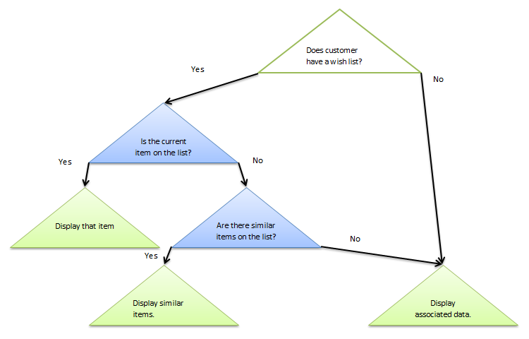
Decision trees are predictive in that they allow data to be aggregated out to a choice. The above example is fairly simplistic, but more in depth decisions could take an entire transaction database and determine customer shopping habits based off of purchase times, products, locations, etc.
The primary disadvantage to using data analytics is in making business decisions on faulty or misunderstood data. This can be seen in false correlations. For instance, based off of a clustering technique, analysis reveals a correlation between the purchases of apples and toilet paper. Seeing this, managers make a business decision to place toilet paper next to apples in the hopes of raising their sales even further. However, this correlation could have no causation between the two data points, and may in fact lower sales of both.

Reference
Brown, M. (2012, December 11). Data Mining Techniques. Retrieved January 9, 2013, from Developer Works: http://www.ibm.com/developerworks/opensource/library/ba-data-mining-techniques/index.html?ca=drs-
Coronel, C., Morris, S., & Rob, P. (2012). Database Systems: Design, Implementation, and Management (10th ed.). Boston, MA, USA: Cengage Learning.

