Running Head: SOURCING

PPI Project Resource Sourcing: In-House, Outsource, or Hybrid
Jered McClure
Walden University

PPI Project Resource Sourcing: In-House, Outsource, or Hybrid
Plush Packet Incorporated (PPI) is intent on updating their aging website to meet the demands of a global audience. However, the method in which PPI should go about this upgrade is still a question. There are three primary alternatives that management must consider: an in-house build by PPI development staff, outsourcing the entire project to a consulting agency, or a combination of these two factors. The end result should be a product that PPI will be able to use and expand upon for years to come.
An in-house build has two primary benefits over an outsourcing model, flexibility and cost. Flexibility comes from the sheer ownership of the project and application. However, along with this comes costs, having the product built in-house means these costs should remain relatively low. That being said, an in-house build maintains several faults.
Building in-house requires that PPI accept the possible lack of skills that their staff may not possess. This will result in a weaker product which could be prone to programming errors and shoddy code. Moreover, PPI may lack the resources required to complete the project in a timely manner. While initial cost estimates may make the in-house build seem viable, long term resourcing may lead to higher costs.
On the other-hand, outsourcing the project resolves the issue of resourcing and code quality, but in turn leads to several other faults. Outsourcing has the primary benefit of requiring much less resource overhead for PPI. This means that the risk of long term cost bloat is minimized. Additionally, an outsourcing agency will be able to specialize in the area of web development, meaning their code will be much more mature.
Nevertheless, outsourcing will remain the more expensive option due to contractual obligations. Further to this, there will be much less flexibility when it comes to altering the website since all code will be managed by the outsourcing agency. Moreover, documentation about the website’s operation and code structure would remain with the outsourcing organization, perhaps leading to market risk for PPI.
A positive way around all the faults which can occur with an in-house build and the market risk that an outsourcing agency portends is in combining the positive aspects of an in-house build with the positive aspects of outsourcing. For instance, PPI could use the resourcing components of a consultant agency to provide contracted resources to program and operate on code. Combining the in-house expertise of PPI’s products with outsourced resources means that the entire resourcing load does not need to hang entirely on PPI. Moreover, PPI could outsource basic hardware and software, thus removing the mundane aspects of data center management and allowing PPI to focus more readily on product development.
Below is a weighted matrix comparing and contrasting the benefits of each option:
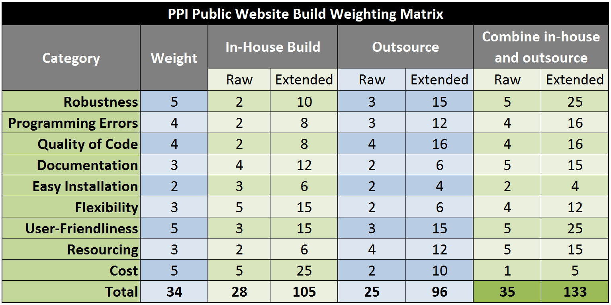
The public website is not the only project that PPI are currently developing. In fact they are working on implementing a new inventory management system, and a customer support system. Each of these could have potential bleed on effects from the choices made about the public website. Specifically, benefits and risks surrounding resourcing arrangements and using the outsourcing agency across multiple projects.
Primarily is the benefit that the outsourcing agency could provide the resources needed to complete the other two projects, as well as the public website. Having their input from the start could mean that integration of these three systems may be a possibility without requiring a third interfacing system to join the three. Furthermore, there are bound to be cost savings in terms of using the agency across all three projects.
However, there still remains some risk that outsourcing may cause. This primarily surrounds contractual agreements and how the organization will provide services. PPI must define in detail what services the outsourcing agency is to provide, when they are to provide them, and exactly how much it will cost. The preferred option here would be a contract following the line of a cost plus reward fee. Whereby, the contracted agency provides a level of support to PPI and if provided above contracted agreement a reward will be tendered by PPI. In this way, PPI can be assured the contracting agency will provide the highest level of support with the lowest level of risk.

Reference
Schwalbe, K. (2014). Information Technology Project Management (7th ed.). Boston: Cengage Learning.
Walden University. (NA). About. Retrieved January 25, 2013, from Plush Packet Incorporated: http://media.waldenu.edu/media/Media1/PPI/website/aboutUs.html

