Running Head: Data Center Signage

Data Center Signage: PPI Data Center Labels

Jered McClure

Walden University

Data Center Signage: PPI Data Center Labels

Clear, concise, and efficient labeling of PPI’s data center will ensure a timely response to any data center change, maintenance, or emergency which may occur. That is, knowing where all servers are located based on a alphanumerical logging system, as well as, all infrastructure hardware (PDUs, CRACs, or Networking rows). Anyone who enters the data center should be able to, at a glance, find their way to any specified server without having to search every single server cabinet row.

The below data center layout shows how all rows and infrastructure equipment should be labeled. In addition to this, each individual piece of hardware in each rack should be clearly labeled with their hardware name and location. E.g. if server PPI-WEBHOST is located at position F-7 then it should have a label on the front and back of the server case stating [F-7: PPI-WEBHOST]. In this manner, anyone doing any kind of maintenance will immediately know where they are, or anyone looking for this server will know where to find it.

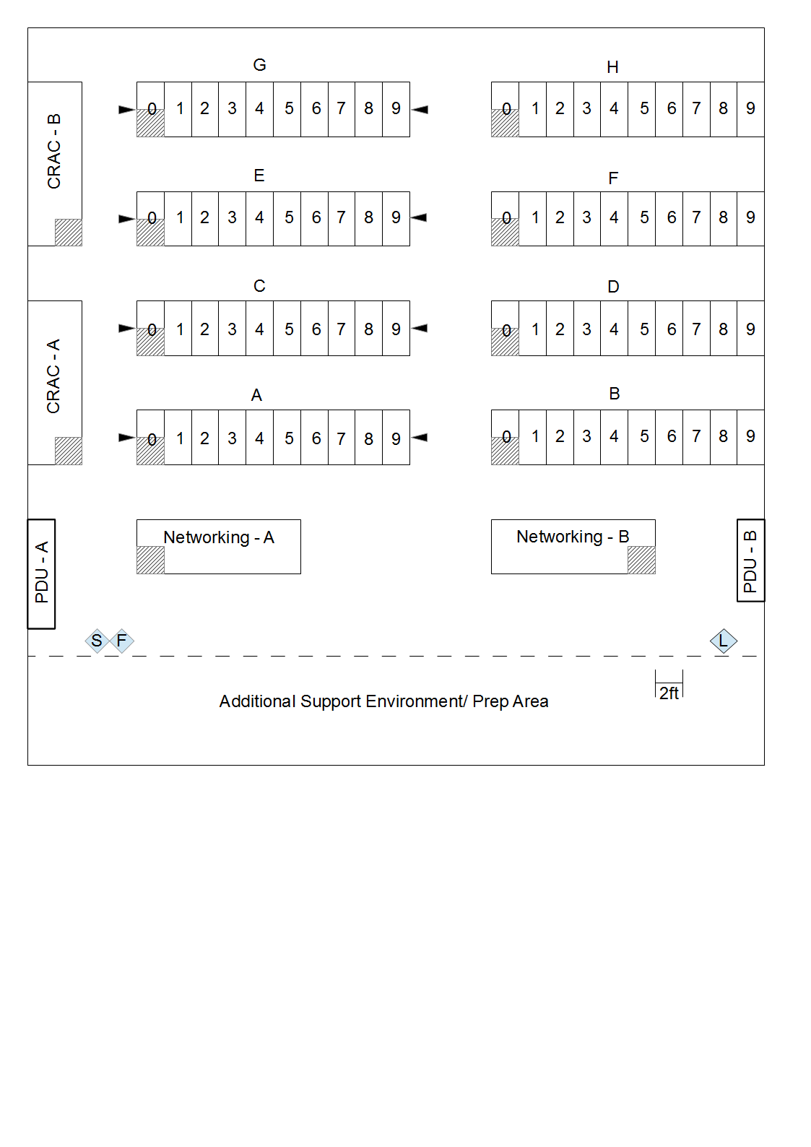

This labeling schema follows with the previous data center plans using VMs and extra hardware. Growth is ensured through a rack by rack roll out.

As cable tags can become cumbersome and too numerous to maintain, all cable paths and locations should be documented via clear labels on switches and rack hubs. That is, plugging an Ethernet cable into port 1 on hub “a” (below) will route data to port 1 on hub “b”. Similarly, power from port A2 is routed to ports A1 for electrical sockets. This ensures that cable routes are known, without having to manage and maintain an ever increasing cable tag library. All a technician needs to do is look at the port letters and numbers.



All permanent signage in the data center is to be placed on engraved or printed plaques. E.g. emergency procedures, server rack row letters/numbers, power receptacles. While the initial outlay on these signs will be more than hand printed labels, it will ensure that the signs are not lost or easily damaged beyond readability. All dynamic signs should be printed and adhered to the hardware and/or cables in question. This will be done using a DYMO label printer with adhesive labels (DYMO, 2011).

In addition to permanent signs being placed on engraved or printed plaques, emergency signs should have lights highlighting them for ease of reading. These lights should be attached to backup power supplies in order for them to remain operational in case of electrical outages.

As PPI have chosen to build their data center in Australia, language choices are pretty clear. However, in order to ensure that emergency signs are readable by anyone who enters the data center, the language choices for these signs should be expanded. English should be the primary language on all signs; emergency signs should include Mandarin and Hindi. These languages are chosen based on the regular occurrence of Indian and Chinese nationals within Australian businesses.

Signage, while not considered the most important aspect in data center operations, is as important as the hardware it contains. Clear, concise, complete notices displayed throughout PPI’s data center can mean the difference between reacting to a fire in five seconds and thirty seconds, in which time millions of dollars of equipment could be damaged. Understanding what is where and how to get from here to there is not only helpful in disasters, but for maintenance personnel who must maintain the data center on a daily basis. After all, time is money.

Reference

Alger, D. (2005). *Build the Best Data Center Facility for Your Business.* Indianapolis: Cisco Press.

Alger, D. (2010). *Grow a Greener Data Center.* Indianapolis: Cisco Press.

DYMO. (2011). *DYMO*. Retrieved May 24, 2013, from DYMO: http://global.dymo.com/enAU/Home/default.html