Running Head: ORACLE DATABASE BACKUP

Oracle Database Backup: Physical and Logical
Jered McClure
Walden University

Oracle Database Backup: Physical and Logical
Database Backup of Physical Files:
The below is a mockup of a remote server backup location. That is, storing the backup files in a remote cloud server. The ORACLE_BACKUP directory would exist on a dedicated backup server, with all files multiplexed to these folders for backup safe keeping.
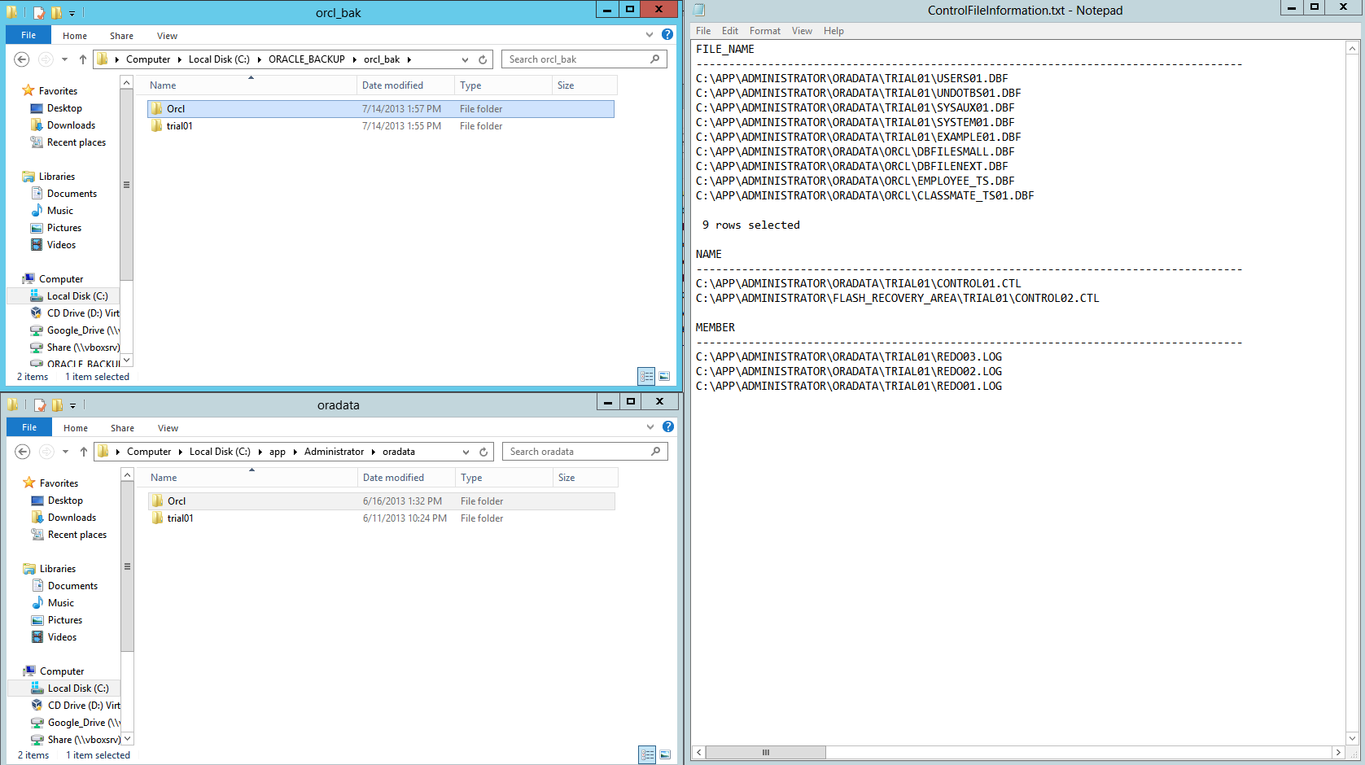
Directory contents of the trial01 database backup:
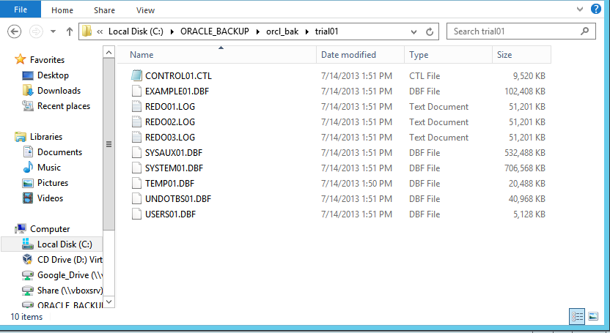
Why is Archive Log Mode optional in Oracle?
The Archive log mode enables the database to restore itself back to a specific point in time based on the information contained in the redo log. However, this redo log grows at the same rate of changes made to the database itself. As an example, given a core systems upgrade, where data must be imported from a different system (e.g. AS/400), the data must go through a transformation routine which causes many updates, inserts, and deletes to occur. Each of these changes must be stored in the redo log. If the table these changes occur on is extraordinarily large, the redo log will fill faster than space can be allocated by the OS. This in turn crashes any changes which would have occurred as the database must be able to archive data while it is in archive log mode.
With this in mind, Oracle has ensured that DBAs can turn archive log mode off whenever it is not really required. That is, during the run time of the transformation routine, the DBA will not need to restore to a previous database snapshot as the database is being filled for the first time from an existing dataset elsewhere. Once the database is filled, and all transformations are complete, the DBA can then turn archive log mode back on so as to ensure future data integrity.
Two logical failures which require backup restoration:
A logical failure is one in which database functionality is not compromised, on the data that exists on the database. Examples of this are user change errors or corruption of a system’s data stream. The user change error is usually when a massive change is implemented by a user, and then committed, only to discover that the data is incorrect. A data stream corruption is one where data being input by a system interface is interrupted or otherwise hampered in such a way that data is incorrectly loaded to the database. Each of these would require the logical restoration of data but not the physical restoration of the database or tables.
Two physical failures which require backup restoration:
A physical failure is one where the database or database tables or irrevocably lost or destroyed. That is, the hardware that the database resides on malfunctions beyond repair, or the physical files are deleted. Hardware failures are quite common on high transaction systems, that is, where hard drives fault and discontinue operation. File deletion is not as common, but is generally due to user error in some way shape or form. In either case, these failures would require the physical restoration of database files from backup, along with the logical restoration of any missing data.
SQL Query Evidence
Finding out Database Files and Database Shutdown
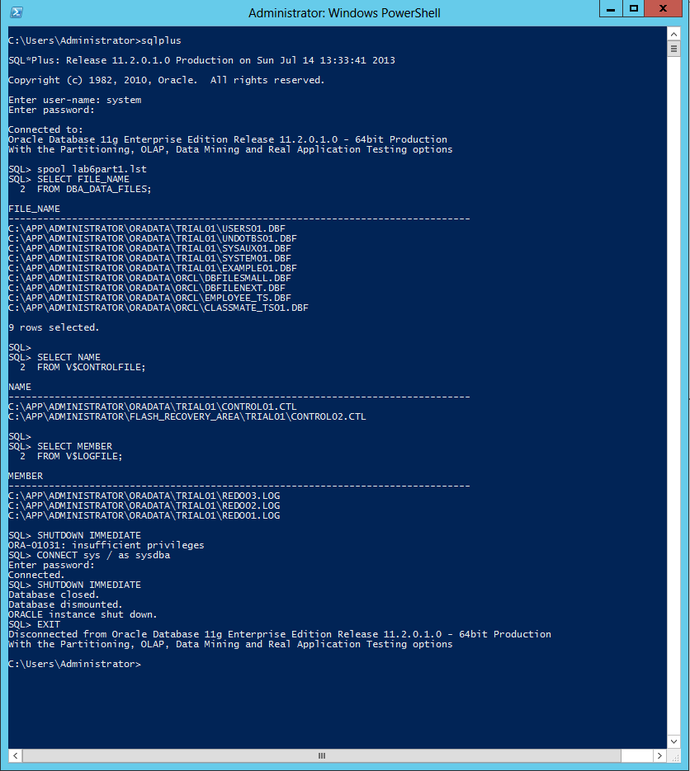
Creating a Database Dump file on user SCOTT
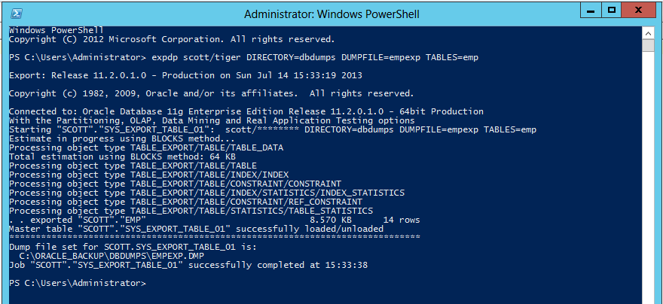
Importing the EMP table for user SCOTT after having dropped it:

Reference
Poweel, G., & McCullough-Dieter, C. (2010). Oracle 10G: database Administrator: Implementation & Administration. Boston: Cengage Learning.

