Running Head: PROCESS MANAGEMENT OWNER

Process Management Owner: Who is Responsible?
Jered McClure
Walden University

Process Management Owner: Who is Responsible?
Process improvement responsibility takes many forms at many different levels in an organization, and typically relies on the professional environment upheld by the management of that company. In some organizations, this means that everyone can have a hand in making process improvement decisions. However, these are usually unstructured environments where a manager is a loosely clad ideal and everyone is generally responsible for their own proficiencies. By and large, a person or group is usually the owner of process improvement and helps guide the overall plan in order to meet strategic guidelines for the organization.
Having everyone be the owner of their own process improvements, means that there is less of a chance that those improvements will fall by the way side. Additionally, since everyone is a subject matter expert in their own area of influence, they usually know the best way to improve processes within their sphere of responsibility. However, the fall back to both of these is that if everyone is working to improve their own processes, no one is working on the work that needs to get done. Similarly, some processes may overlap, meaning that redundant process improvement plans could be implemented by competing individuals.
Organizing a process management department, group of process managers, or even a process champion all amounts to the same thing, but at different scales. It centralizes the process management resources, knowledge, and skills into a single area thereby freeing up everyone else to get their own work done. Also, since this centralized unit has all process improvement projects flowing across their desk, they can prioritize and push for the most important improvements and ensure no redundant projects are implemented. However, this centralized unit is not without its own flaws.
A centralized process management group can stagnate under its own influence, similar to how any department can become a silo. Process improvement is done for process improvement’s sake, rather than for making the process’ customers happy. Also, since the centralized unit is now in charge or process management, other departments/groups/staff can begin to slack off in their own process administration. After all, they are no longer the ones responsible for the processes being implemented.
Given the theoretical situation of a manufacturing organization consolidating two of its three plants, processes would need to be adjusted to meet the new status quo. A quick matrix of strategic process importance reveals the following:
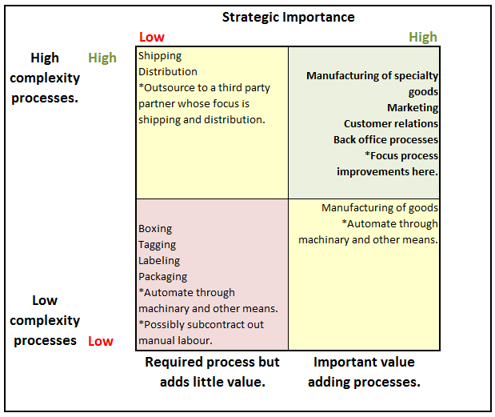
Immediately it is seen that most of the technical side of consolidating the two plants is not an issue. The engineers hired by the company will manage the manufacturing automation without fault as that is what they are paid to accomplish. Where the process managers need to focus their sight on, however, is in the area of specialty manufacturing, marketing, customer relations, and back office processes.
To ensure that processes are ready for this consolidation, the process management group would coordinate with the strategic planning/steering committee to determine the best route for updating and modifying existing processes, as well as, adding any new processes which may be required. This would require gathering all relevant process information and consolidating it into a single BPM repository, whereby, a project plan can be built. Processes would then be analyzed in detail and redesigned as needed to meet the company’s new requirements.
Implementation of the new process would take place through a coordinated effort of the management team, as well as, the entire process management group. All processes would be tested against existing processes before final approval is given. This means that in some cases processes would need to be redesigned until they met strategic goals, or even tossed out in favor of existing processes. In the end, everyone affected by the new processes will need to be trained and made aware of the benefits of the changes. Communication of the new processes would be done through two avenues, via the company’s management, and via the process management group’s process champion.

Reference
Harmon, P. (2007). Business Process Change: A guide for Business Managers and BPM and Six Sigma Professionals (2nd ed.). Burlington, MA: Morgan Kaufmann.

