Running Head: TREES

Week 5 Discussion: Trees
Jered McClure
Walden University

Week 5 Discussion: Trees
Trees are, in essence, hierarchical data structures whereby the root node is located at the top, and leaf nodes are at the bottom (Sherrod, 2007, pp. 303-305). A great example of such a tree is the DNS naming system which is the backbone of the internet. Each URL contains the essence of hierarchical structures, for instance: www.waldenu.edu. The top end DNS server of “.” is the root of the URL hierarchy, edu is the first layer of the tree, waldenu is the second layer, and www is the leaf.
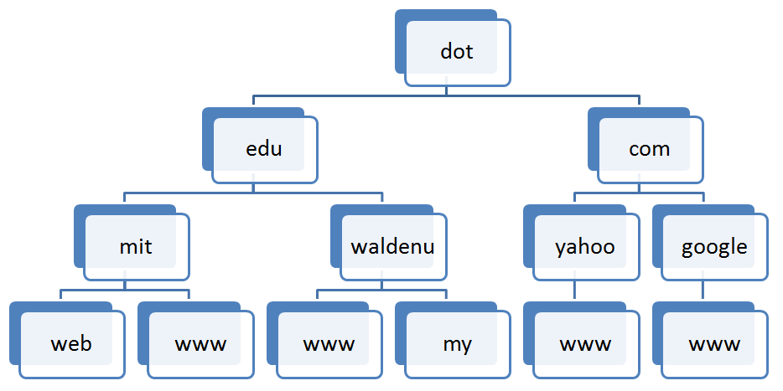
Another tree structure, that is commonly found when dealing with relational databases, is the naming conventions related to finding data. For instance, in MSSQL the database server sits above the databases as the root, the databases and tables act as internal nodes, with individual tuples acting as leaves:
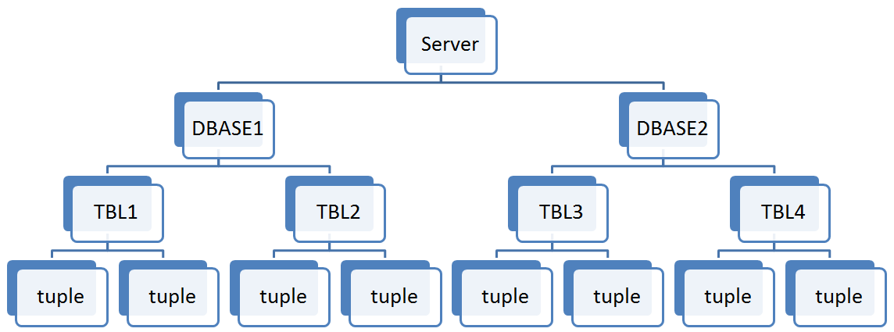
Java programming uses Trees throughout the entire lifetime of object handling. Objects are stored in packages which are themselves stored in the hierarchical structure of the Java system library. Whenever one writes code, they write their code in a hierarchical manner, with classes acting as nodes, and methods acting as branching structures leading to endpoints unknown. While the code itself may be spread over many object, those objects interact within the hierarchical tree of the Java language.

Reference
Sherrod, A. (2007). Data Structures and Algorithms for Game Developers. Boston: Course Technology.

