Running Head: INDEXES, VIEWS, AND STORED PROCEDURES

SQL Queries: Indexes, Views, and Stored Procedures
Jered McClure
Walden University

SQL Queries: Indexes, Views, and Stored Procedures
- Create an index on the job column of the employee table.
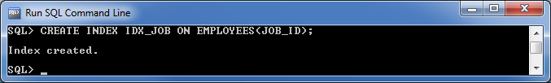
- Create an index on the combination of department identification number and basic salary columns of the employee table.
- Create a view Emp_vw containing the employee number, the employee name, the department number, and the department name. Ensure that the view allows users only to view, and not to update, the data.
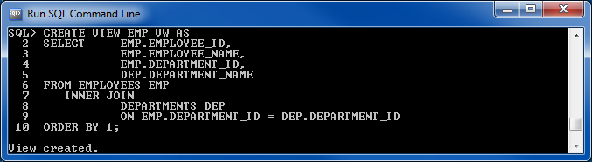

- Create a view emp_dept_view containing the employee name and department name columns from the employee and department table.
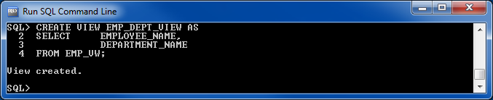
- Create a function that returns the day of the week for a specified date.
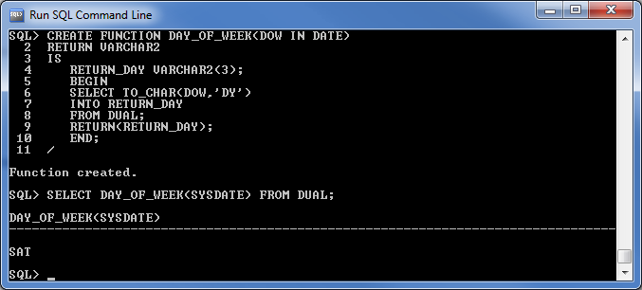

- Create a procedure that accepts a department number, computes the total basic salaries for that department, and displays both the department number and the total basic salaries.
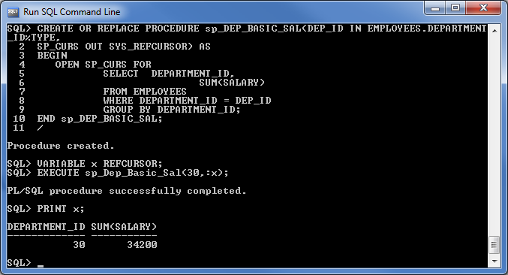
- Create a procedure that accepts an employee number and a job. In the procedure, determine if the employee has the specified job or not. If the employee has the job, display the employee's ID number. If the employee does not have that job, display the employee's name and his or her actual job title.
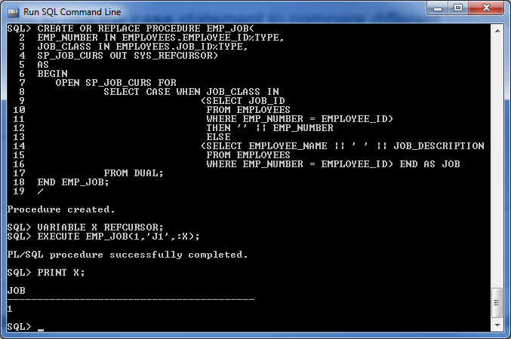
- Create a trigger to store a copy of any record deleted from the employee table into a table called Emp_temp. Assume that the Emp_temp table has the same structure as the employee table.
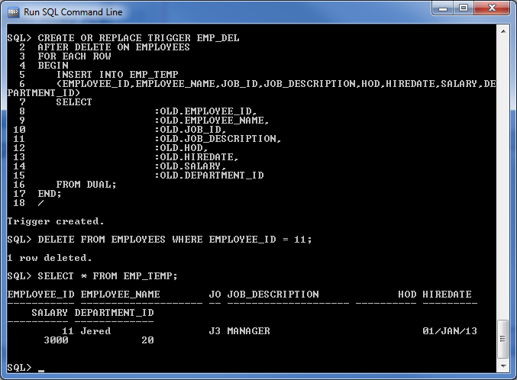
- Create a trigger that displays the message "Emp table updated" when an update to the employee table increases the employee's basic salary.
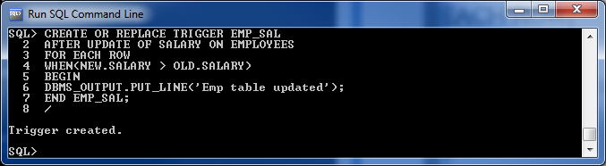
Reference
Coronel, C., Morris, S., & Rob, P. (2012). Database Systems: Design, Implementation, and Management (10th ed.). Boston, MA, USA: Cengage Learning.

