Running Head: HTDEMO

Week 5 Application: Hashtable Demonstration
Jered McClure
Walden University

Week 5 Application: Hashtable Demonstration
The HTDemo class demonstrates the use of a hashtable object. First objects are inserted into the hashtable based on a String key. The values for each key represent the integer value of that key. A user is then asked for input to retrieve a value from the hashtable. If the input the user provides does not match a key in the hashtable, an error message is displayed. Otherwise, the value for that key is returned. At the end, the system prints out the hashtable’s contents in a formatted table.
I chose to change all key values to uppercase characters. This allowed me to pass a toUpperCase() method against the user input for retrieving key value pairs. As such, the word “one” and “ONE” will return the same value. If this were a full-fledged application, I would have worked more at catching user input errors and ensuring that no keys would collide with one another.
In order to return the keys of each associated pair in the hashtable, I chose to convert a KeySet() into an array of type Object. This allowed me to pass a “for” statement iteration loop over the array and return each value in the hashtable. I could have used an Iterator object, but felt this was a much more concise and easier to manage method of returning values.

Index
UML Class Diagram
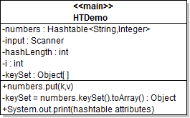
Output
