Running Head: PERFORMANCE MONITORING

Oracle 11g Performance Monitoring
Jered McClure
Walden University

Oracle 11g Performance Monitoring
- Oracle – Oracle Enterprise Manager 11g
  - Feature 1: CPU usage
    - This allows the DBA to monitor and compare CPU usage statistics across a range of computers in an Oracle grid. Alternatively, it will allow them to monitor the system CPU usage for a single installation so that intensive CPU loads do not bog down server performance.
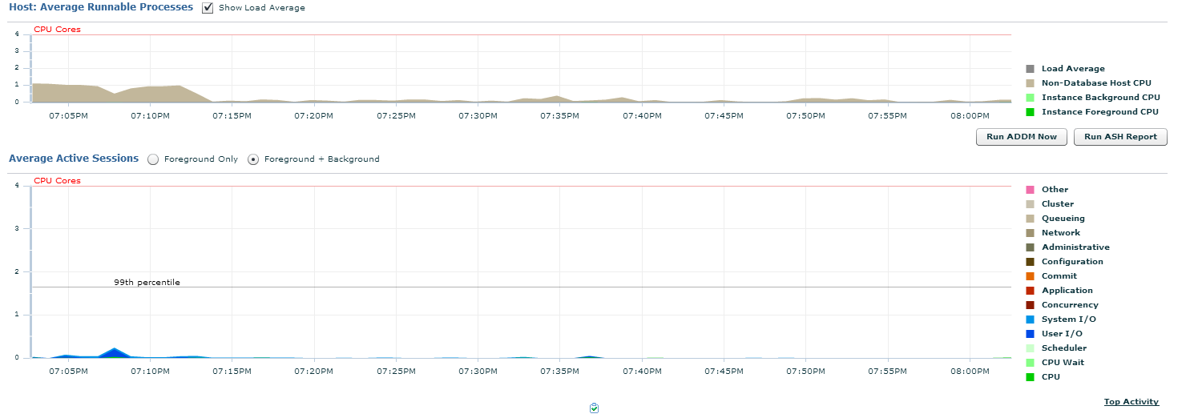
  - Feature 2: I/O monitoring
    - System throughput, e.g. I/O, can be monitored through OEM. With this information, the DBA is able to understand peak load times and allow for proper system resources to be made available. This data includes latency checking, bandwidth monitoring, and system requests.
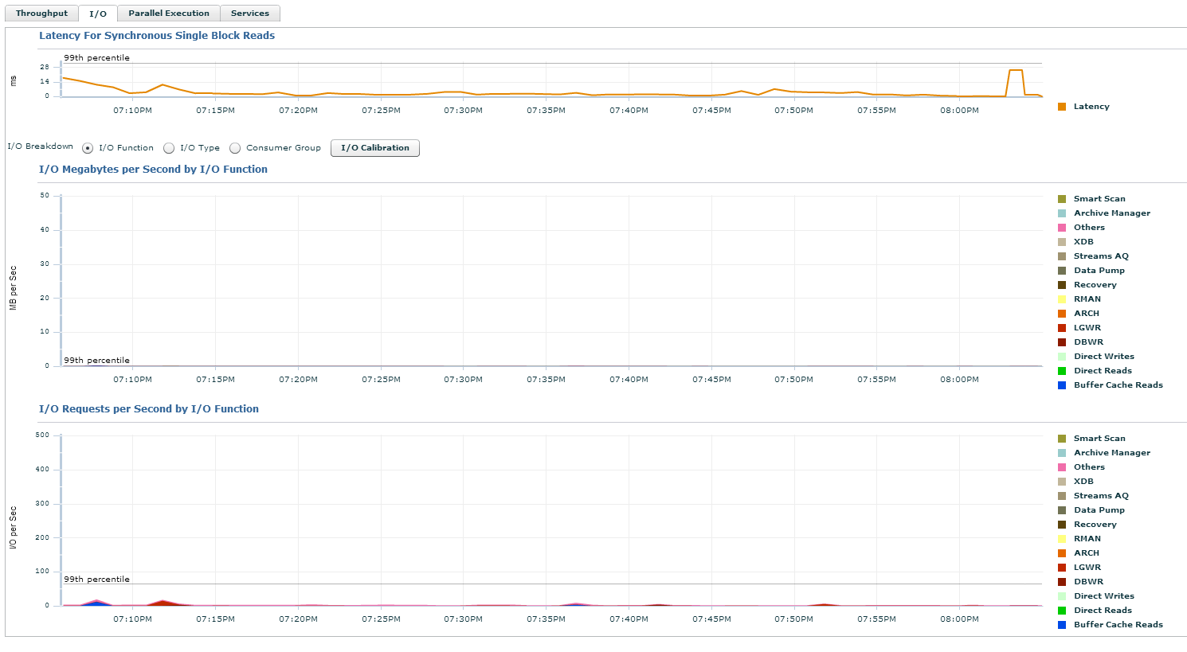
  - Feature 3: Oracle service monitoring
    - OEM service monitoring allows give the DBA a hand up in terms of understanding which services are causing the most drain on resources. Since all services are specific to Oracle, there is no confusion about whether the service in question is a database drain or a server drain. Moreover, services can be drilled down into to understand what exactly it is that is causing the system drain. E.g. commit statements, administrative functions, or user I/O.
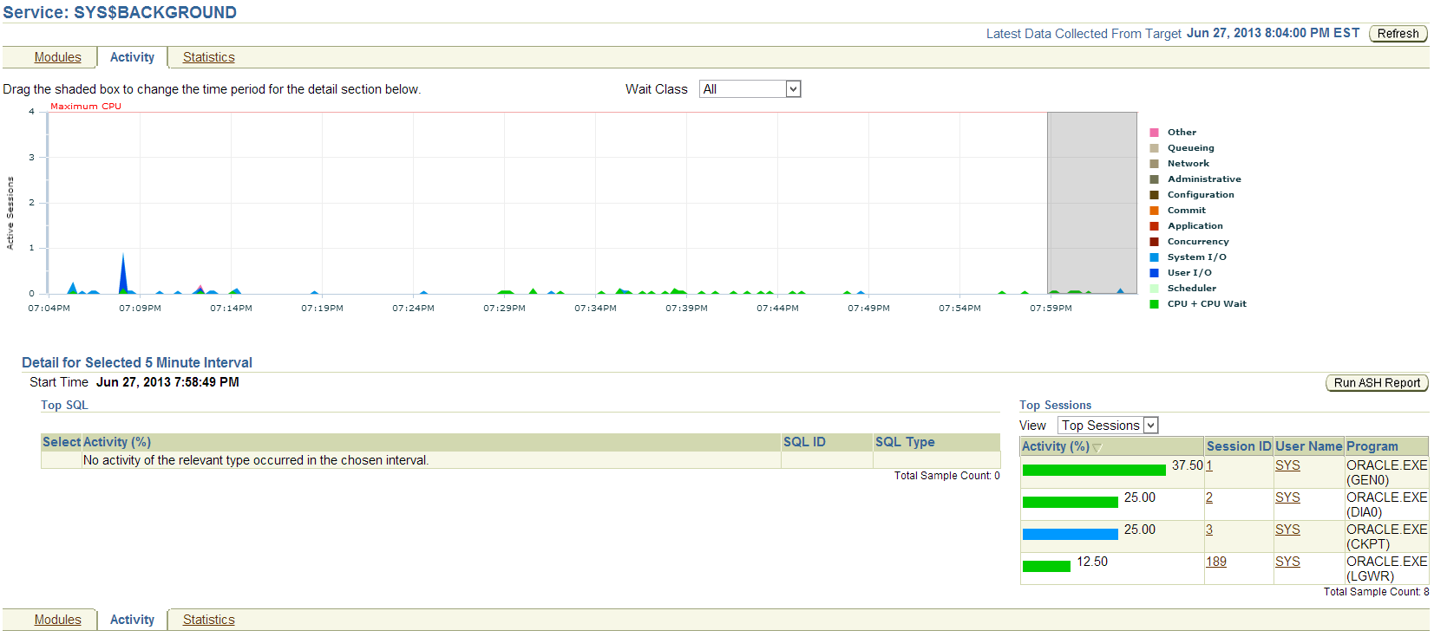
  - Particulars
    - Overall, the OEM allows a great deal of in-depth knowledge and interaction for the DBA. It simplifies their job allowing them to focus on the important aspects, rather than becoming bogged down in details and code. The greatest thing it does, however, is allows the DBA to visually see the impact activities are having on database performance.
- OS – Windows Server Manger 2012
  - Feature 1: Event Monitoring
    - Event monitoring can make the difference between understanding what a system error means and wandering blind through the alleyways of Google. A visual aid, the event detail view allows the DBA to drill down into server warnings to better manage and maintain database performance characteristics. When a critical error occurs, it even allows the DBA to enter Event IDs to immediately search for errors which would otherwise require digging through log files manually.
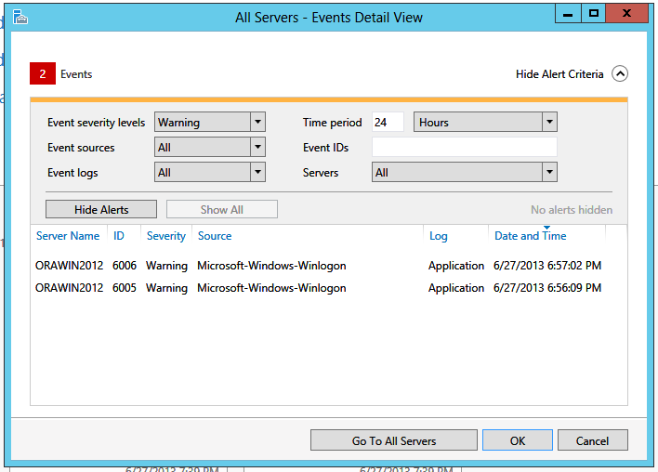
  - Feature 2: Storage Monitoring
    - Window’s server manager file and storage services monitoring capabilities give the DBA the power to understand and adapt to storage requirements as the Oracle grid grows and changes. From a stand-alone perspective, it ensures the DBA can stay many steps ahead of storage space in the event of large data influx. Disk monitoring, and even storage pools can be setup, thereby ensuring virtual servers maintain a healthy feed of storage whenever and wherever required.
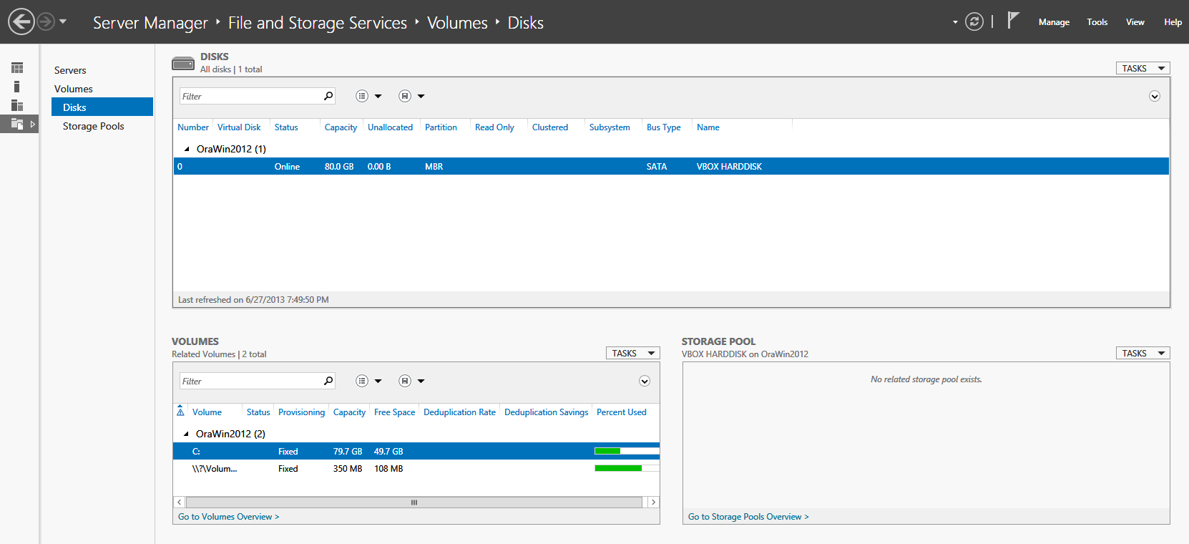
  - Feature 3: Windows Task Manager
    - The task manager is usually given much less credit than it deserves. In essence, it gives the DBA instantaneous up to the moment data on how the server is operating. This data covers CPU usages, RAM usage, and even user I/O via Ethernet data. Where the OEM can provide this data, Windows 2012 can provide it seamlessly and at a moment’s notice.
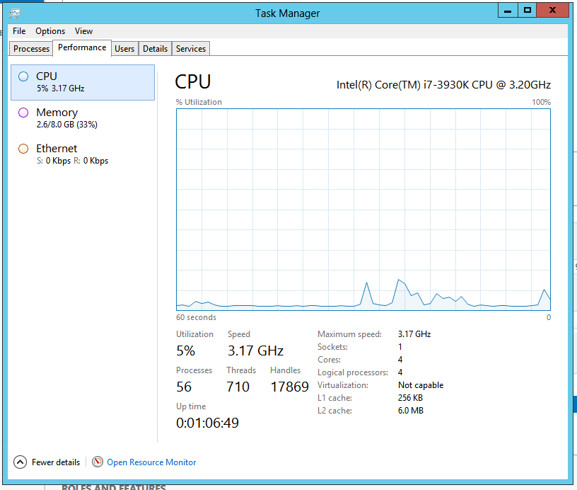
  - Particular
    - The OS tools in Windows 2012 are much improved over previous versions of the server. However, they do require the server to be run with a GUI. This means that system resources are taken away from the database and given to the running and maintenance of the OS. While modern systems can manage this without much issue, full performance guarantees may require the system be run in text mode rather than GUI. All that being said, a single server can be setup as the virtual host, and thereby bypass all of this as each database would be setup in the virtual pool in text mode.
- Third Party: Quest Spotlight
  - Feature 1: Email Notifications
    - This is quite possibly the most important feature of this software package. The ability to know exactly when and if a server is having performance issues cannot be underrated. It is likely that a DBA will know through their user-base that a database is performing poorly, but having the server email the DBA before users are even aware of an issue can make the difference between customers staying or leaving.
  - Feature 2: Visual interaction of resource utilization
    - While OEM and OS tools do give visual representations of resource utilization, Spotlight takes this to a whole new level. It allows the DBA to see visually I/O interaction between users and the database, CPU usage by users, checkpoint alerts, log alerts, service alerts, SQL process statistics, and disk storage metrics. However, it does this in such a way as to be intuitive, one glance allows for total database performance understanding.
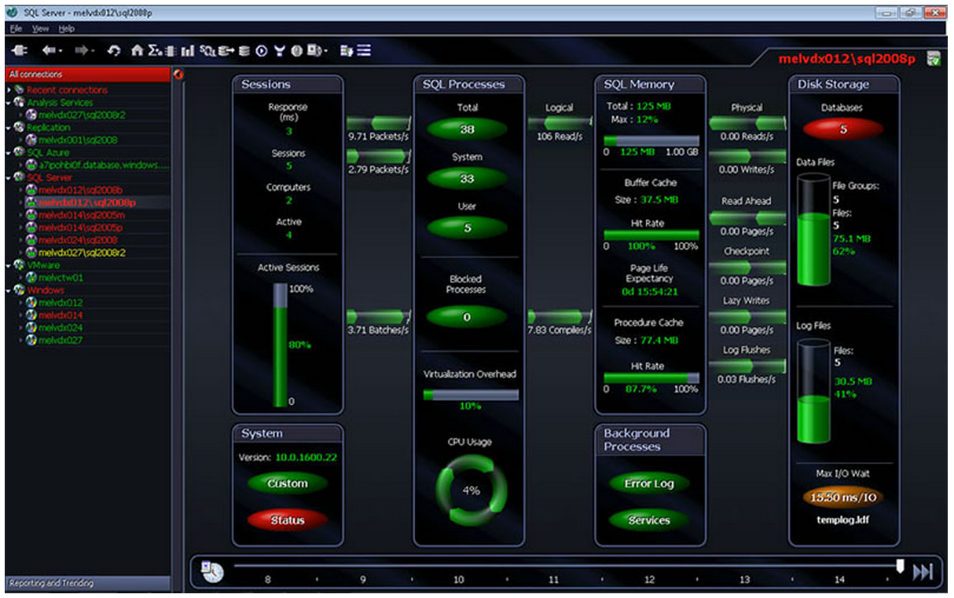
(Dell, 2013)
  - Feature 3: Drilldown
    - Just as Spotlight enhances visualizations over OEM and the OS, these visualizations can be drilled down into to provide unprecedented amounts of detail. For instance, clicking on a service allows the DBA to drill into the metrics of that server and even into the core database statistics brought back from the V$ views in Oracle. No fuss required in terms of understanding when and where the performance views are located.
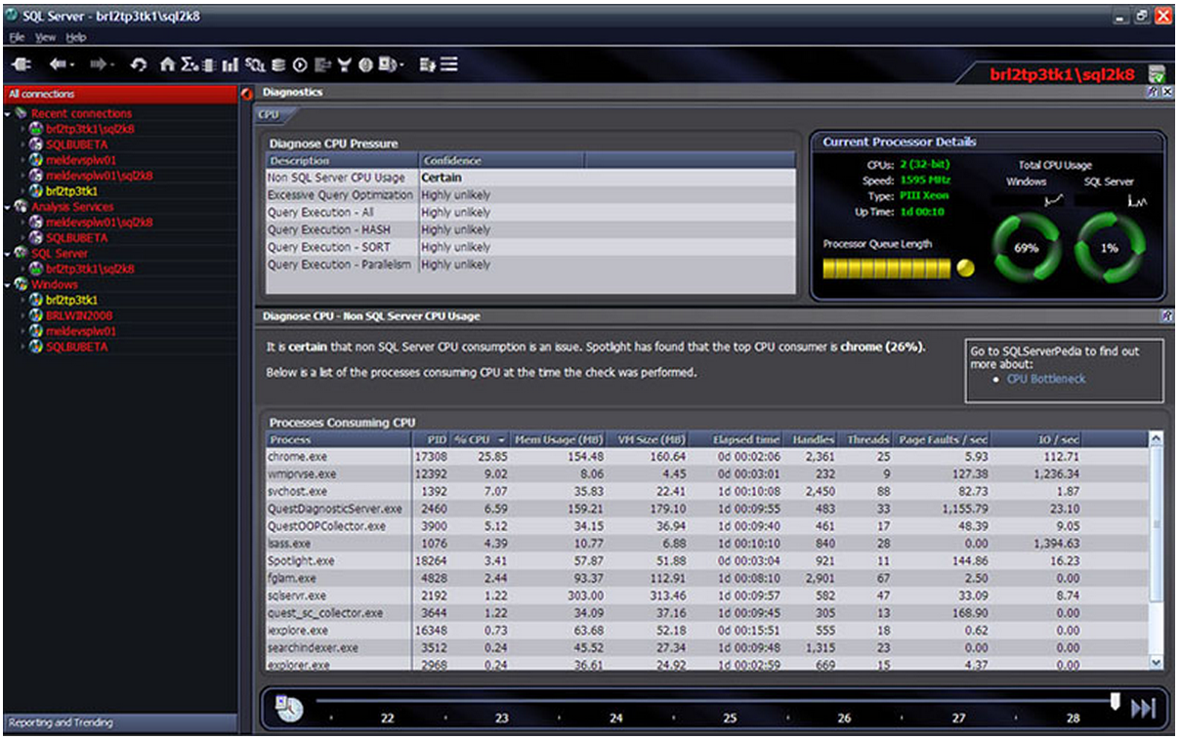
(Dell, 2013)
  - Particular
    - Spotlight has to be one of the very best tools to use in terms of database performance monitoring. It empowers the DBA and allows them to focus on customer satisfaction through performance guarantees, rather than script management and overwhelming details. Moreover, it does this in such a way as to make the entire process feel harmonized. In essence it embodies human computer interaction, but from the level of a DBA.

Reference
Dell. (2013). Spotlight on SQL Server Enterprise. Retrieved June 25, 2013, from Dell Software: http://www.quest.com/spotlight-on-sql-server-enterprise/
Microsoft Corporation. (2012). Windows. Retrieved 2012, from Microsoft: http://windows.microsoft.com/en-US/windows/home
Poweel, G., & McCullough-Dieter, C. (2010). Oracle 10G: database Administrator: Implementation & Administration. Boston: Cengage Learning.

