Running Head: VIRTUALIZED NETWORK INFRASTRUCTURE

Designing Virtualized Network Infrastructure
Jered McClure
Walden University

Virtualized Network Infrastructure: Plush Packet Incorporated (PPI)
Optimization of server room space, application streamlining, data center cost savings, and protecting the environment can all take place through the logical application of virtualization technology in the data center. Virtualization enables PPI to consolidate multiple servers into a few high end servers, thereby reducing the overall cost of upkeep and leasing. Additionally, this enables PPI’s administrators to gain a greater control over hardware inefficiencies and application resourcing. Furthermore, virtualization ensures that PPI can meet changes in the marketplace on using on demand hardware resource routing.
Two methods of virtualization are possible, A) Virtualization through cloud hosting, B) Virtualization of in-house applications and hardware. Both of these options bring their pros and cons. That is to say, neither is truly an “all-inclusive” data center solution. However, combined they offer an incredible market advantage.
Cloud services, such as that offered through entities like TAS Managed Services in New South Wales, are managed data centers which offers capital savings through economy of scale. That is, these organizations offer their services to corporations thereby consolidating data center requirements into one key location. The downside to such a service is that hardware and application support are based on licensing terms and agreements which may not always be in the best interest of the organization at hand. However, for sheer size, availability, and continuity services these organizations are hard to beat.
In house hardware and application virtualization gives PPI the greatest amount of control over the systems used. As stated, virtualization enables PPI to consolidate applications and hardware into fewer servers, and thereby server racks. This in turns enables capital to be re-routed into storage solutions and application development. The downside to this is that all hardware and application support must be done by PPI’s information technology team.
A combination of these two options is the recommended course of action. For offsite backup, disaster recovery, and development applications/hardware, use the cloud based solution. This will ensure that catastrophic local occurrences do not have a direct effect on business continuity. Additionally development resources can be added and subtracted ad-hoc through the hosted solution’s dynamic storage availability.
For all daily core and support applications, these should run off of local data center resources. This ensures immediate availability through local high speed connections, as well as, business flexibility. That is, if the hosting provider proved untenable, core systems are not affected to any great extent. Furthermore, since core systems are on PPI’s hardware, PPI can ensure full governance is maintained.

Virtual System Interaction Layers
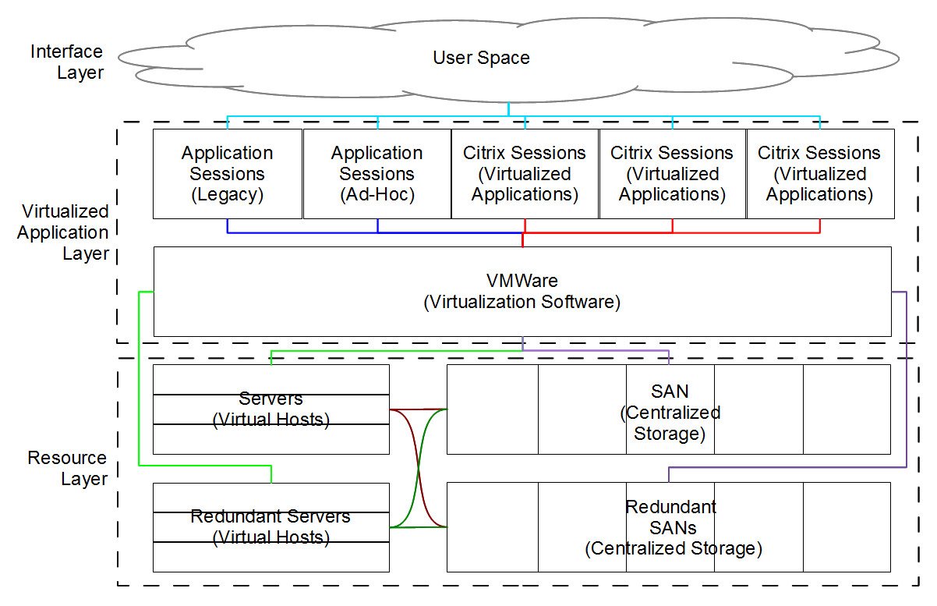
Similar to the OSI model, the bottom of the stack is the physical layer, whereas the top of the stack is the user interface layer. Additionally, this diagram shows how servers and storage are interconnected so as to ensure maximum uptime in case of hardware failure. That is, if one of the virtual hosts go down, the redundant virtual host will kick in and use the primary SAN storage, unless of course it is down. In which case, it will automatically move to the redundant SAN. All of this occurs without the application and interface layers being aware of it, as the virtualization software managed hardware resource routing.

Server Rack Diagram
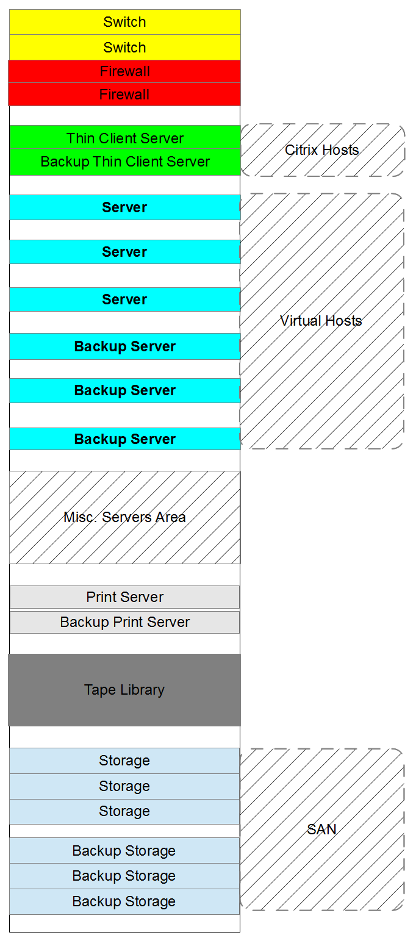
All hardware in the server rack is sorted based on weight, and cooling requirements. That is, the heavier SAN storage components are at the bottom of the rack and Virtual hosts are spaced out so as to provide optimal airflow. In addition to this, all hardware is duplicated so as to provide the greatest possible uptime in case of hardware failure. That is, all individual hardware pieces are backed up, and the backups are interconnected so as to have multiple failover points in case of recovery.

Network Connectivity Diagram
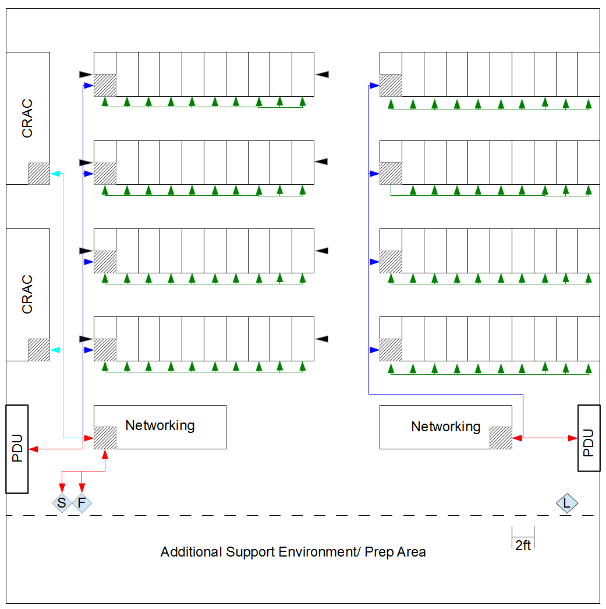

Reference
Alger, D. (2005). Build the Best Data Center Facility for Your Business. Indianapolis: Cisco Press.
Alger, D. (2010). Grow a Greener Data Center. Indianapolis: Cisco Press.
TAS Managed Services. (2013). Home. Retrieved May 10, 2013, from TAS Managed Services: http://www.tasol.com.au/index.html
VMWare Inc. (2013). Home. Retrieved May 10, 2013, from VMWare: http://www.vmware.com/au/

