Running Head: SQL SCRIPTS

SQL Scripts: Sorting, Grouping, and Nesting Data
Jered McClure
Walden University

SQL Scripts: Sorting, Grouping, and Nesting Data
- Use a join to display the employee identification number and employee name of all employees of the production department.
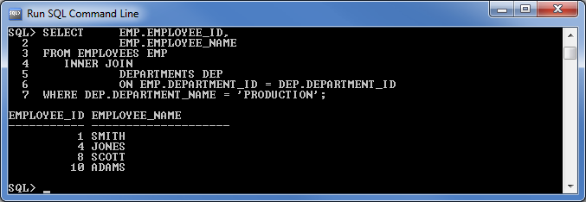
- Use a subquery to display the employee identification number and employee name of all employees of the production department.
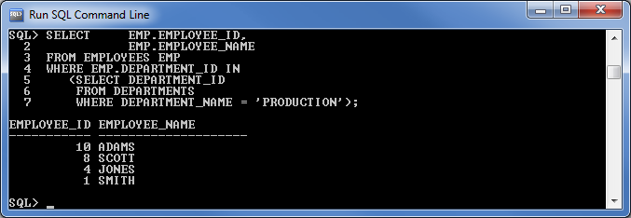

- Display the details of the employees who have been hired after the employee Jack was hired.
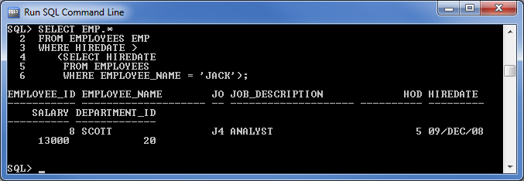
- Display the employee name, department number, and job description of all employees who do not have the same job title as the employee Scott.
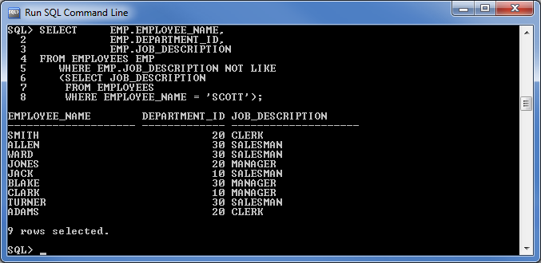

- Display the average, maximum, and minimum salary of all the employees.
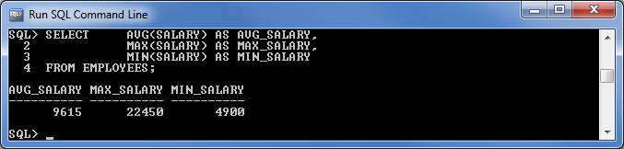
- For each department, display the department number, the average, maximum, and minimum salary earned by the employees of the department. Sort the data by average salary.
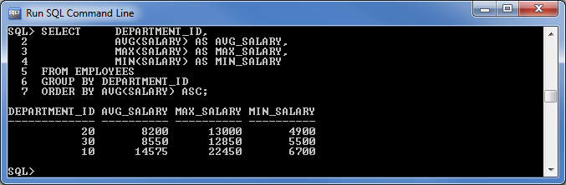
- Find the highest salary earned by any employee in each job category. Display only those jobs where the maximum basic salary is more than $10,000.
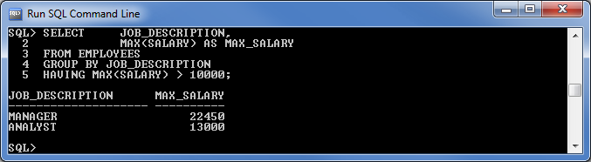

- Find the total number of employees working under each particular head of department (HOD). Display only those department heads that have a count greater than 3.
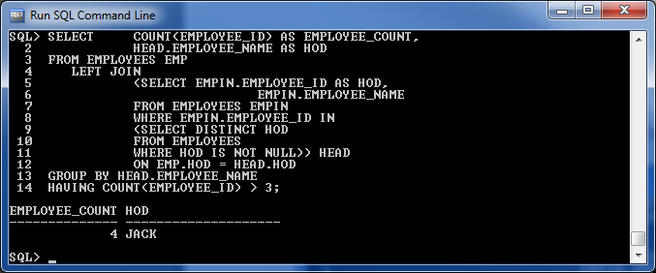
- Display the number of employees in each department.
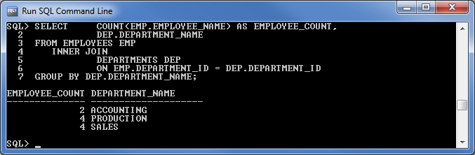

- Display the department name and average salary of all the employees in each department. Sort the output alphabetically by department name.
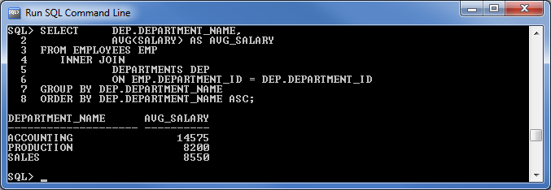

Reference
Coronel, C., Morris, S., & Rob, P. (2012). Database Systems: Design, Implementation, and Management (10th ed.). Boston, MA, USA: Cengage Learning.

