Running Head: PM SOFTWARE COMPARISON

Project Management Software Comparison
Jered McClure
Walden University

Project Management Software Comparison
Four tools which can be used to better help manage project flow are Microsoft Project, OpenProj, RedBooth, and Jira. Each of these has a specific use and reason to exist and fits in nicely depending on the size, scope, budget, and schedule of the project in question. Below is a chart comparing and contrasting these four tools across eighteen different attribute alignments:
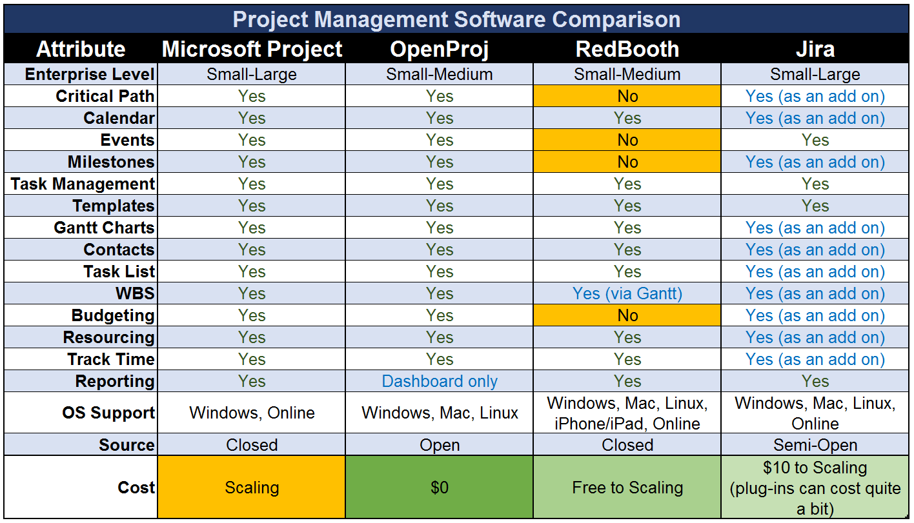
Starting with Microsoft Project, its use is both wide spread and accepted universally as the “de facto” project management tool. Its use ranges from the smallest of businesses all the way to multinational conglomerates. However, Microsoft’s licensing agreement can, at times, be a hindrance to its acceptance by some organizations wishing to save money. This is where OpenProj steps in nicely.
OpenProj is a free to use open source project management tool with nearly all the same functionality as Microsoft Project. One would think that its market price of $0 would mean it would be the “go-to” project management application of choice. However, being an open source application, means that its level of support is only viable to the extent that the OpenProj community wishes to maintain. This is even more evident considering OpenProj is no longer actively developed and is technically an abandoned piece of software, even though it is still fully functional.
Redbooth and Jira are both collaboration platforms for project management. Redbooth is a closed source platform with a highly active organization in full support. Jira is in a similar position. However, they have a wide development community backing their semi-open (open to commercial clients) source application. In this regard, their product is a jack of all trades.
Where these two applications fit is in how they are being used. Redbooth, in particular, is ready to run right out of the box, allowing for team collaboration and project issues tracking. Jira, on the other hand, is more for the project team ready to expand their project management capabilities over a period of time. That is, they know what they want initially, and are unsure as to their full requirements down the path.
If the organization in question is a small to medium enterprise, then a combination of OpenProj and Redbooth are likely the best of all options for the cost to benefit ratio. However, if the organization in question is larger, or has a bit of capital to spare, then Microsoft Project or Jira are highly desirable. Nevertheless, the primary concern of a project management application should be in how it fits with an organization’s skill base. If the organization in question is highly skilled with Microsoft products, this may be a moot point, if there is an excellent in-house development team, perhaps Jira is a better option overall. If there is a culture of open source mentality, OpenProj perhaps looks like the best option, and if there is no development team, but a sense of collaboration is required, then Redbooth is definitely the way to go.

Reference
Gantt Project. (2011). GanttProject. Retrieved March 27, 2014, from GantProject: http://www.ganttproject.biz/
Microsoft. (2013). Project Professional. Retrieved March 27, 2014, from Microsoft: http://office.microsoft.com/en-au/project/professional-project-management-desktop-software-project-professional-FX103797571.aspx
Redbooth. (2014). Redbooth. Retrieved March 27, 2014, from Redbooth: https://redbooth.com/
Serena. (2014). OpenProj and Projects on Demand. Retrieved March 27, 2014, from Sernea: http://www.serena.com/index.php/en/products/pod-update/

