Running Head: INCREASING AVAILABILITY

Increasing Availability: Evaluating a Cost Cutting Proposal
Jered McClure
Walden University

Increasing Availability: Evaluating a Cost Cutting Proposal
A review of our current system setup is required in order to first fully understand what the proposed solution offers to our organization. Our current system is composed of primarily three distinct nodes: the users who operate on the system, the server which provides our application services, and the backup system which ensure our data integrity for posterity. This solution was built during a time when our organization was much smaller and had fewer needs then what our current environment envisions. A downtime of just four hours results in a capital loss to our company of $40,000. Moreover, we have a history of having at least two of these occurrences a year, which is plainly unacceptable. To really drive this home, a total system failure would result in a 24 hour downtime or a loss of more than $240,000 to the company.
Figure 1: Current System
From this standpoint, any solution other than what we currently have will be a massive improvement to availability and safekeeping of organizational capital. As such, the question is not whether the proposed solution will increase our availability margin and thus safeguard our income, but rather is the solution really solving all our availability concerns? On the surface, the proposed solution seems to resolve our worries about a 24 hour downtime, and moreover, ensures that the yearly 8 hours of downtime are no longer an issue. This is done by implementing a secondary remote application cluster which at system failure becomes live and takes over system operations.
However, this is not the end of the story, and does not resolve our problems to the fullest extent possible. The proposed solution has a failover time of four hours. This means that, while the data itself will have a recovery point in the seconds range, the recovery time will still take four hours at each failure. Further to this, is the reliance on the operational capacity of the redundant server, it will have an availability exactly the same as the live server, which means there is always the possibility of it going down at the same time. Finally, if the secondary server has a corruption of data, there will be no way to restore the live system to operational status, ever (as there is no backup solution).
Figure 2: Proposed Solution
Taking a step back from the technical side of things, a look at the savings this solution would offer is required. The quoted ROI is roughly $58,000 a year. This is based on the fact our company would no longer require a backup solution for our system. Disregarding the fact our systems would lose any chance to recover to a point in time in the past; this number seems to be simply made up out of thin air. Their cost estimate is that it takes our technicians four hours a day to back up our systems at $40 an hour. As our salaries are not made public, nor is the time it takes to complete a backup, this is simply number washing.
However, a proper analysis of their offering based on current knowledge provides the following. Currently, our systems have a possible yearly outage down time of 1920 minutes, or 32 hours. The proposed solution would actually increase this downtime to 2040 minutes, or 34 hours a year. This is primarily due to not factoring in failover testing in the solution and over factoring the MTFO. Additionally, the ROI is -13.33% over five years, or a loss of $20,000, unacceptable.
Figure 3: Proposed Solution ROI
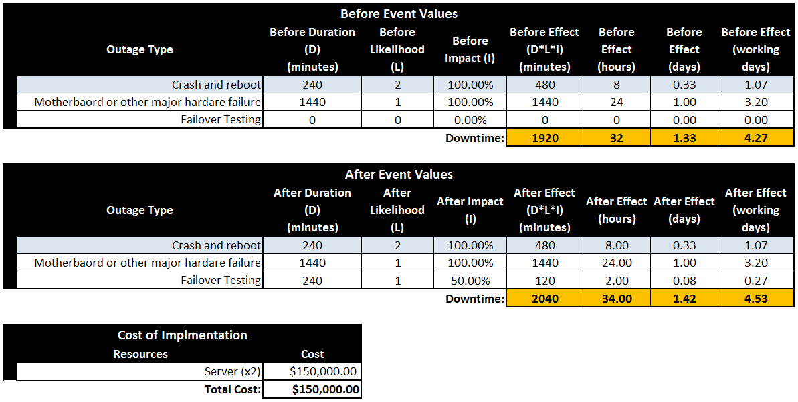
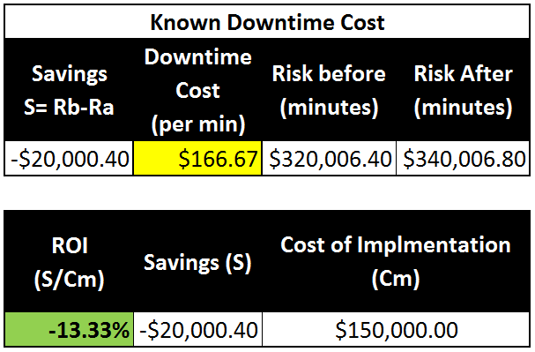
As the proposed system is providing no savings, where does this leave us? The truth is in the details. The lack of a backup system means the proposed solution is inherently flawed. If there is ever a need to restore further back then the most recent image (e.g. virus, data corruption, or patch flaw) there would be no way to do this. As previously stated, if the redundant server becomes corrupted, there would be no way to ever restore data to the live system. In essence, the proposed solution is not advisable, and is potentially worse than our current setup.
However, an alternative proposal, which is built upon the ground work already provided, is as follows. Develop a secondary failover cluster, in a remote data center, with a redundant heartbeat connection to ensure failover ability. Use a failover management system, such as Double-Talk, which provides a MTFO in the seconds range, a RPO in the seconds range, and the ability to restore to a point in the past without resorting to backup tapes. Moreover, do not remove our current backup system, as it will ensure a total disaster does not leave our organization without a recovery solution. Finally, move to a Storage Area Network (SAN) rather than on-board storage, in a redundant array.
This solution offers shorter failover times, ensured data recovery point objective, long term data availability, and alternative failover routes for system components (e.g. failover either the system or the storage, or both, depending on failure type). There is still room for availability improvement, primarily around making the local arrays redundant. However, in terms of increasing the initial availability of our system, this setup offers availability much more in line with what is required.

Figure 4: Alternative Solution
This leads us to the solid facts about the ROI of the new proposal. The current setup has an average yearly downtime of 1920 minutes, per year. The newly proposed solution would have an average downtime of 1.75 minutes, per year. Averaging the cost of the new SANs and an additional application server to the same price of $75,000, for an overall implementation cost of $150,000, the new ROI is 213.14% or $319,714.73 over five years. Increasing availability, and decreasing costs, at the same time.

Figure 5: New Proposal’s ROI
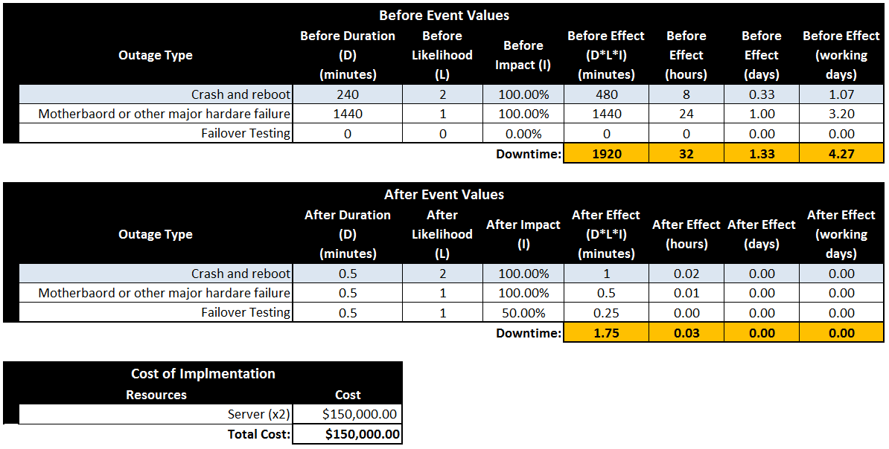
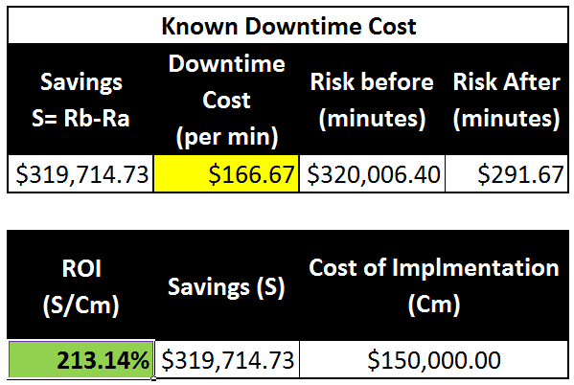

Reference
Inc., S. A., & Highlyman, W. (2009, April). Why Back Up? Retrieved April 16, 2014, from Availability Digest: http://www.availabilitydigest.com/public_articles/0404/journalspace.pdf
Klebanoff, J. (2009, September). End-to-End High Availability and Disaster Recovery. System iNews, 35-40.
Stern, E. M. (2003). Blueprints for High Availability (2nd ed.). Indianapolis: Wiley Publishing, Inc.
Vision Solutions. (2013). Double-Take 7.0: Overview. Retrieved May 6, 2014, from Vision Solutions: http://www.visionsolutions.com/downloads/Product-Sheets-E/PS_DTA_WIN_E_130617.pdf
Vision Solutions. (2013). Double-Take 7.0: Solution Suite. Retrieved May 6, 2014, from Vision Solutions: http://www.visionsolutions.com/downloads/Product-Sheets-E/PS_DTA_WIN_E_130617.pdf
Vision Solutions; Eric Payne. (2013, October 31). Double-Take Avaialbility 7.0 Demo - vSphere. Retrieved May 6, 2014, from YouTube: https://www.youtube.com/watch?v=v8Abwv8IwZ4

