Running Head: REVERSE KEY INDEX

BTree: Reverse Key Index
Jered McClure
Walden University

BTree: Reverse Key Index
A BTree reverse key index, as recommended by Oracle, should be used specifically for Oracle Real Application clusters. That is, on databases that require high levels of simultaneous transactions. Unlike a normal BTree index, every entry in the index, except the ROWID, is reversed. These types of indexes are only used by the Oracle optimizer when a single record search or a full index scan is required (Poweel & McCullough-Dieter, 2010, p. 435). That is, when multiple I/O connections are trying to read and/or write to the same Oracle block of data.
A good example of this is a transactional sales table named SALES_TRANS:
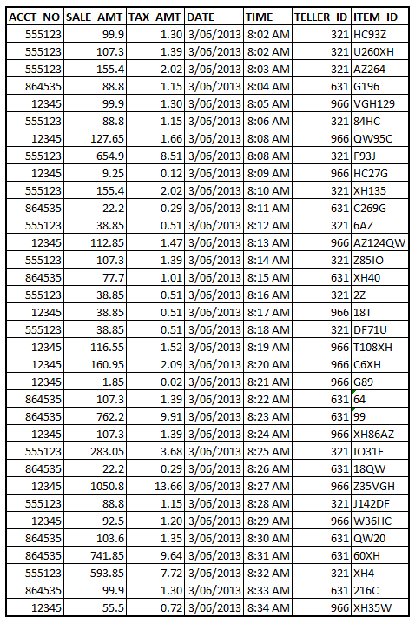
In the above example, tellers 321, 631, and 966 are all competing to enter sales transaction details for three different customers (12345, 555123, and 864535). As the customers are directly interfacing with the tellers in question, the transactions need to be as timely as possible in order to ensure a good customer experience. As such, have a reverse key index on the TIME and ACCT_NO columns would ensure that any entries made to the SALES_TRANS table do not compete for Oracle block space, thereby slowing down I/O times. The above example is small, but over an extremely large organization, say 200 tellers with 10,000 possible customers, a reverse key index will decrease I/O overlap dramatically.

Reference
Poweel, G., & McCullough-Dieter, C. (2010). Oracle 10G: database Administrator: Implementation & Administration. Boston: Cengage Learning.

