Running Head: TECHNOLOGY SUPPORT PROCESS

Technology Support Process: Plush Packet Incorporated (PPI)
Jered McClure
Walden University

Technology Support Process: Plush Packet Incorporated (PPI)
Technology is a business unit built around supporting and managing the organization’s information technology architecture, applications, and data requirements. In this paper is discussed a specific process which Technology performs in relation to service and delivery. That is, the proverbial helpdesk and the process the consultants who manage the helpdesk must perform in order to meet business requirements.
The helpdesk process is a simple one to describe and yet technically challenging to perform since it can involve many different people and crosses several organizational boundaries. However, magnifying and focusing specifically on the process requirements for the helpdesk staff can simplify the understanding of the process chain as it is, in itself, a microcosm of the overall chain. We will consider the Plush Packet Incorporated (PPI) organization as the technology business unit in focus.
In essence a PPI employee logs a work order to the technology helpdesk requesting assistance with a technology issue. The service and delivery consultant reviews the work order and attempts to resolve the issue at their level. If the issue is resolved, they contact the customer and confirm resolution. However, if the issue is not resolved, or the issue is outside the technical capabilities of the consultant then they need to escalate the issue to 2nd level support.
Second level support consists of the Network and Desktop support, Applications support, and Intelligence support. Each of these support channels have their own processes to resolve work order issues, but take input from the initial work order as passed from the helpdesk process. From this point the issue is managed and resolved at the 2nd level until it is passed back to the customer for review. If the issue is not sufficiently resolved then it circles back to the helpdesk for evaluation. The process is only completed when the issue is resolved to the customer’s satisfaction.
The process itself is measured by the time it takes the technicians to resolve an issue and by the subjective customer satisfaction level. Reports are managed and maintained by the Helpdesk team leader who monitors work order work flow to ensure customer issues do not get stuck in an endless dissatisfaction loop. Additionally, since work orders are managed in a system, issue patterns can be found and customer pressure alleviated through proactive response to this derived information.
(Below can be found models for the PPI Technology organization, the overall technology helpdesk process chain, and a drill down to the specific helpdesk process.)

Technology Organization
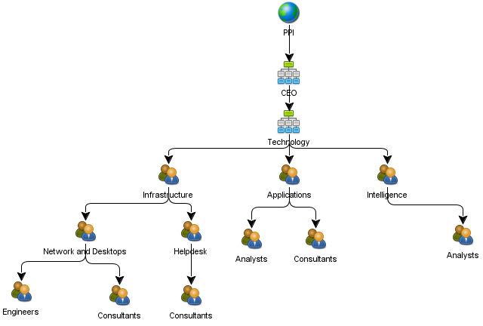

Technology Work Order Support Process Chain
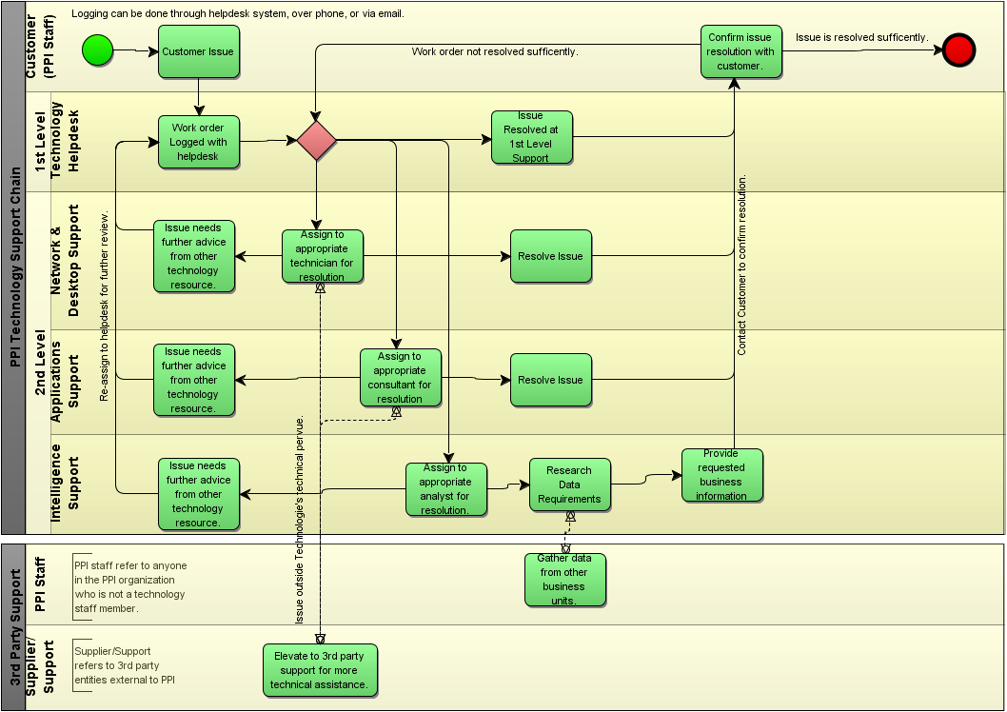

Helpdesk Support Process Chain Drill Down
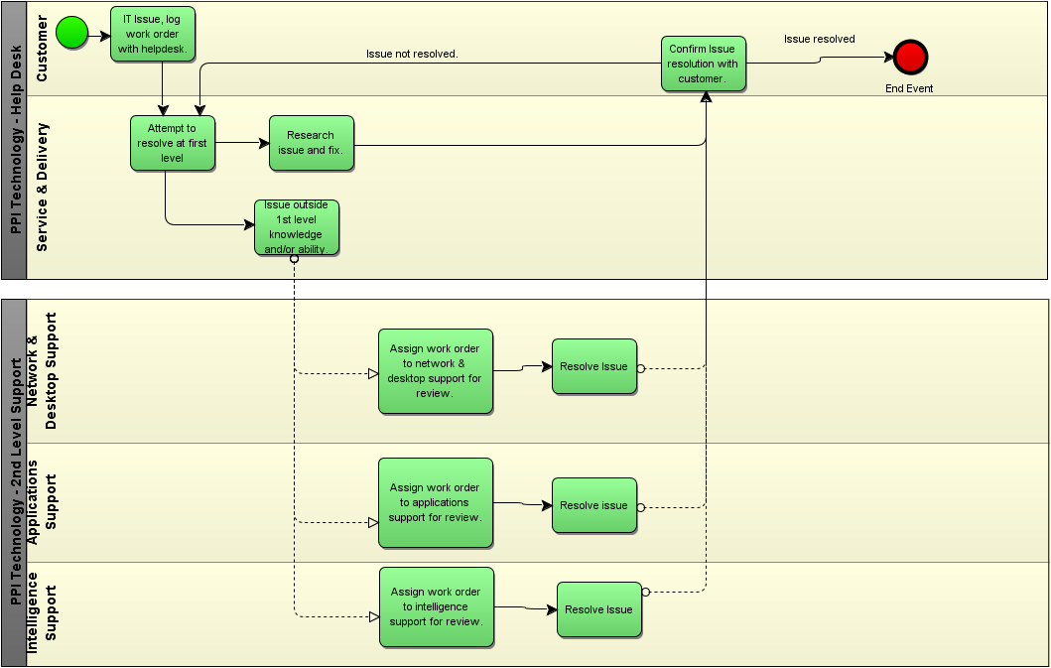

Reference
Harmon, P. (2007). Business Process Change: A guide for Business Managers and BPM and Six Sigma Professionals (2nd ed.). Burlington, MA: Morgan Kaufmann.
Walden University. (NA). About. Retrieved January 25, 2013, from Plush Packet Incorporated: http://media.waldenu.edu/media/Media1/PPI/website/aboutUs.html

