Running Head: INTERMEDIATE SQL QUERIES

Intermediate SQL Queries: Oracle 11g Express
Jered McClure
Walden University

Intermediate SQL Queries: Oracle 11g Express
- The name and data type of every column of the EMPLOYEES table
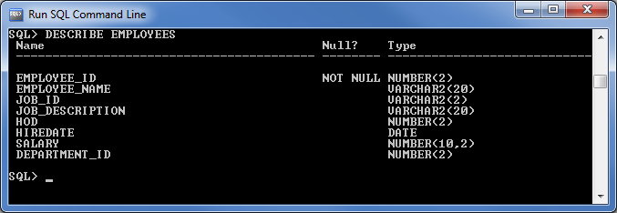
- The values in all rows and columns of the DEPARTMENTS table
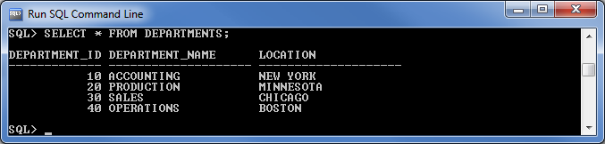
- The employee identification number, employee name, and department identification number for every employee
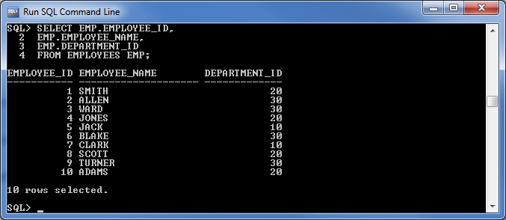
- The employee identification number and salary of all employees earning more than $3,000
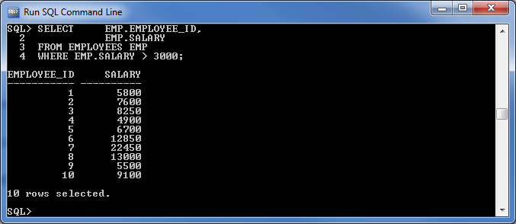
- The employee identification number, employee name, and department name for all employees whose identification number is greater than 103 and less than 203
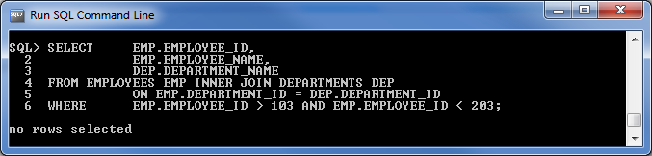
- The employee name, head of the department (HOD), and salary for all employees whose salary is not in the range of $5,000–$ 10,000
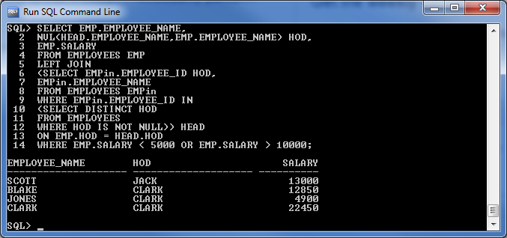
- The job identification number, job description, and joining date of employees who have been hired between December 01, 2007, and June 01, 2008
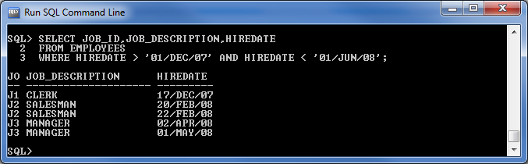
- The complete employee detail for all employees whose last names start with S
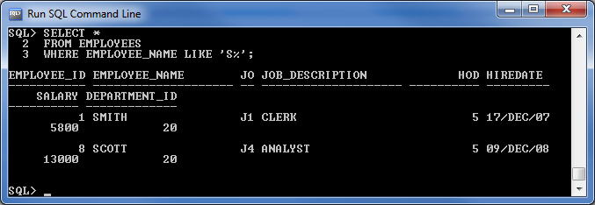
- The employee name and department identification number of all employees belonging to department identification number 10 or 20
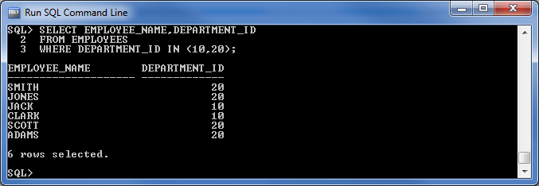
- The employee name, department identification number, and department name for all employees
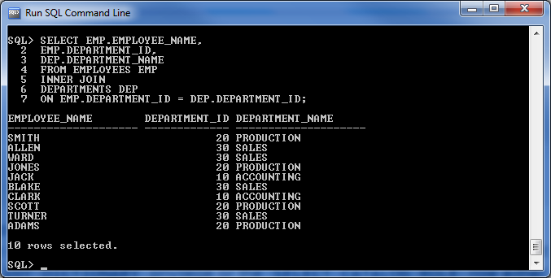

- The employee name, department name, and location of the department for all employees who earn a salary greater than $15,000
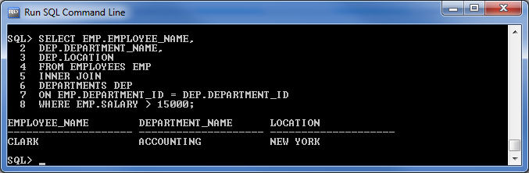
- The employee name and employee identification number along with their HOD's name and identification number
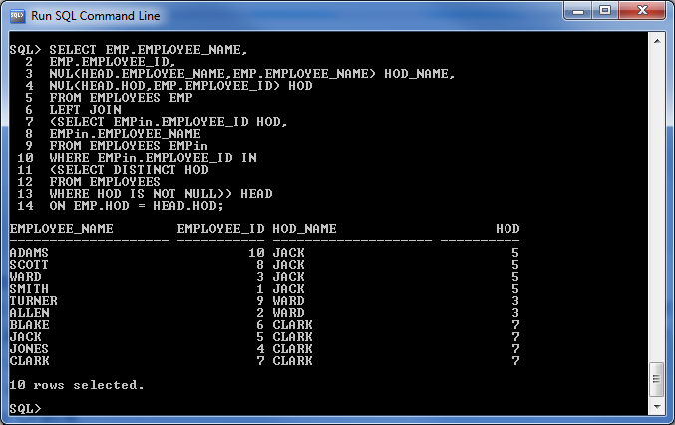

- The employee name, job description, department name, location of the department, basic salary, and grade for all employees
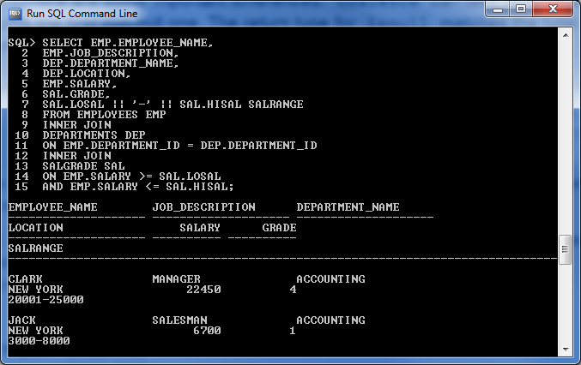
- The employee identification number and joining date for employees who have been hired after Jack was hired
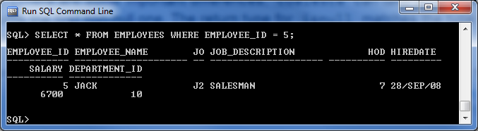
- The employee name and department name for all employees, whether they have a department or not
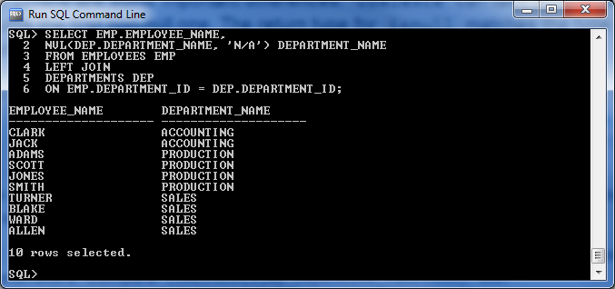

Reference
Coronel, C., Morris, S., & Rob, P. (2012). Database Systems: Design, Implementation, and Management (10th ed.). Boston, MA, USA: Cengage Learning.

