Running Head: USING THE VIGENÈRE CIPHER

Cryptography: Using the Vigenère Cipher
Jered McClure
Walden University

Cryptography: Using the Vigenère Cipher
Using the Vigenère Tableau encryption scheme with a keyword of KEYWORD, encrypt the following message:
IS INFORMATION SECURITY ESSENTIAL
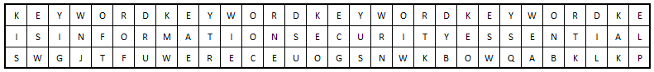
SW GJTFUWERECE UOGSNWKB OWQABKLKP
After encrypting the message, decrypt the following message, using KEYWORD as the keyword:
YRJUW WWRIG JTFUW ERECE LCMKL CIWKR R
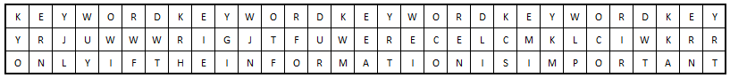
ONLY IF THE INFORMATION IS IMPORTANT
K | E | Y | W | O | R | D | K | E | Y | W | O | R | D | K | E | Y | W | O | R | D | K | E | Y | W | O | R | D | K | E
I | S | I | N | F | O | R | M | A | T | I | O | N | S | E | C | U | R | I | T | Y | E | S | S | E | N | T | I | A | L
S | W | G | J | T | F | U | W | E | R | E | C | E | U | O | G | S | N | W | K | B | O | W | Q | A | B | K | L | K | P
K | E | Y | W | O | R | D | K | E | Y | W | O | R | D | K | E | Y | W | O | R | D | K | E | Y | W | O | R | D | K | E | Y
Y | R | J | U | W | W | W | R | I | G | J | T | F | U | W | E | R | E | C | E | L | C | M | K | L | C | I | W | K | R | R
O | N | L | Y | I | F | T | H | E | I | N | F | O | R | M | A | T | I | O | N | I | S | I | M | P | O | R | T | A | N | T

Reference
Dhillon, G. (2007). Principles of Information Systems Security: Text and Cases. John Wiley & Sons, Inc.

