Running Head: SUPPLY CHAIN MANAGEMENT

Supply Chain Management: Plush Packet Incorporated (PPI)
Jered McClure
Walden University

Supply Chain Management: Plush Packet Incorporated (PPI)
Plush Packet Incorporated (PPI) is an (imaginary) educational games company who market and sale DVDs, plush toys, books, and board games. They also wish to branch into the online gaming sector for older children. Their primary customers are schools/teachers and families, specifically children, although their parents are the monetary target. In order to operate as efficiently as possible, PPI partnered with a major reseller (EduCorp) which allowed PPI to lower shipping costs through outsourcing management. Supplier relations are currently limited to the United States. However, PPI are in plans to include suppliers from international entities, as well.
PPI’s supply chain branches from the raw material suppliers, all the way to the shipping and handling of goods to the customer. The raw materials required for PPIs goods are cotton, assorted chemicals, and wood. These raw materials are then turned into fabrics, threads, plastics, and paper materials. From here the chain manufactures what the customer will receive, which are the DVD’s, books, plush toys, and board games. Since PPI are branching into the online gaming sector, the raw materials required are actually minimized, causing cost savings as media can be digitally transferred directly to customers cutting out the entire supply chain.
The customers, as stated, are schools/teachers and families. As these are two very different groups, two separate marketing campaigns are required. This in turn branches the supply chain, one branch to educational institutions requiring studies on goods and services, as well as, evidence of educational awareness within the products being sold. The second branch is to children who want to have an entertainment experience, but also to the parents of those children who want to know their children are learning something.
Once customers have their product in hand, they want to know that their products will last, and if they are damaged upon arrival, have a means of return for funds paid, or replacement. This requires that PPI have a means of warranty management. Customers are able to contact PPI’s service desk to request replacement of faulty products within a set period of time, so long as they have proof of purchase and evidence of tampering is not found. Customer service management in this regard is important, if a customer receives a faulty product they will not be in a happy mood. Adding to their aggravation through poor customer support will likely give PPI a bad reputation, leading to lower sales.
Supply chain performance is fairly good for PPI due to their partnership with EduCorp. This partnership has led to a decreased time between customer orders and fulfillment of their orders. However, due to PPI having few suppliers outside of the United States currently, means that their supply costs are high. This means PPI must have a high number of days for inventory supply in order to make up for any sudden customer order increases. PPI’s plan to branch out internationally for their suppliers means they will be able to lower their on-hand stock and decrease their supply chain response time dramatically.
The easiest way to see PPI’s supply chain is through a Supply Chain SCORcard as show below:
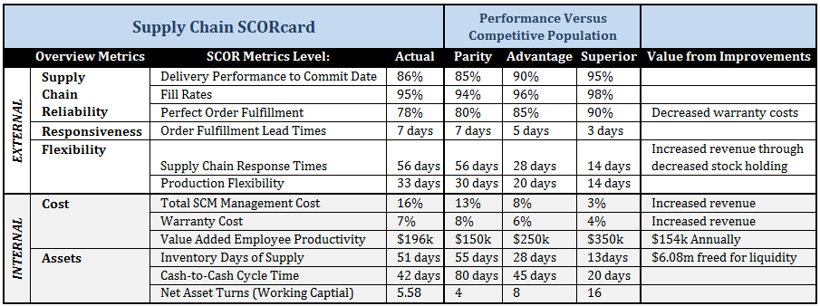
(*data for this SCORcard is made up, as PPI is not a real company)
The supply chain reliability is direct evidence of EduCorp’s role in PPI’s product delivery. However, EduCorp are not the end-all that one would hope from PPI’s partnership. Being that EduCorp’s entire role is to supply and deliver products to end customers; their perfect order fulfillment should be above 80%. By increasing this performance point, PPI will see a direct correlation to their warranty costs through fewer customer complaints and warranty returns.
PPI’s strategy to expand their supply chain to international entities is a smart one when looking at the current flexibility of their chain, on the SCORcard. More suppliers mean a larger number of feeds into the manufacturing process, which lead to faster supply chain response times and product flexibility. This in turn means that the total inventory PPI must keep on hand would be decreased dramatically, as stated previously. Additionally, the time that capital is transferred to suppliers and then returned as revenue would be decreased as supplies would go from raw materials to working products that much faster.

Reference
Harmon, P. (2007). Business Process Change: A guide for Business Managers and BPM and Six Sigma Professionals (2nd ed.). Burlington, MA: Morgan Kaufmann.
Laureate-Media. (NA). ITEC-3030: PPI's Business Strategy. Retrieved January 18, 2013, from Walden University: http://mym.cdn.laureate-media.com/2dett4d/Walden/ITEC/ITEC3030/documents/PPI_Strategy.pdf
Walden University. (NA). About. Retrieved January 25, 2013, from Plush Packet Incorporated: http://media.waldenu.edu/media/Media1/PPI/website/aboutUs.html

Index
PPI Supply Chain
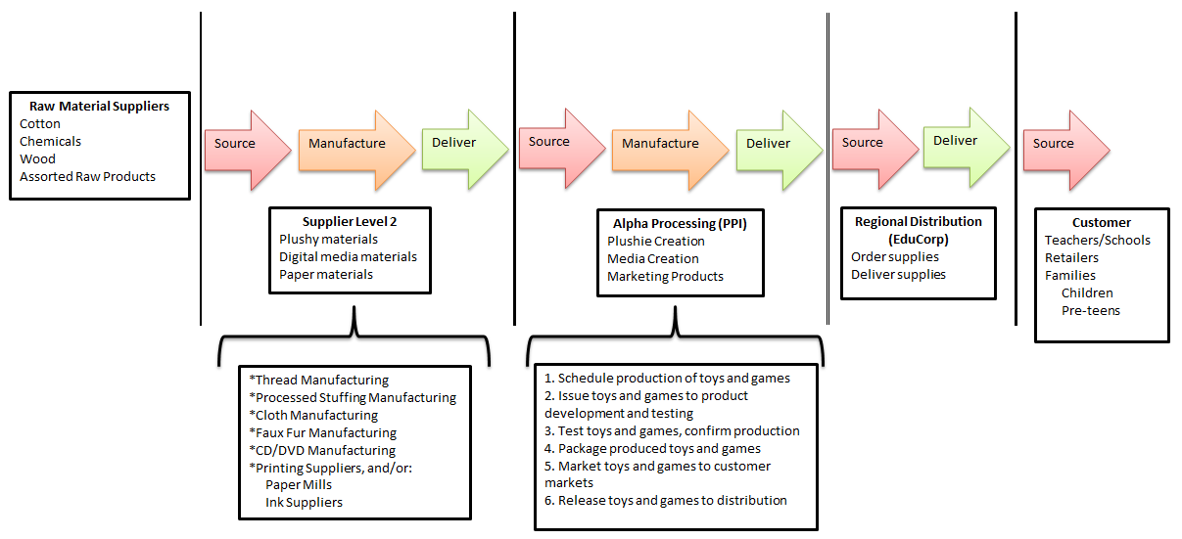
Capital Adequacy Figures
