Running Head: SQL COMMANDS

SQL Commands: Create, Modify, Update, Select, and Delete - Oracle 11G
Jered McClure
Walden University

SQL Commands: Create, Modify, Update, Select, and Delete - Oracle 11G
- On the Start menu, select Programs> Oracle Database 11G Express Edition> Run SQL Command Line.
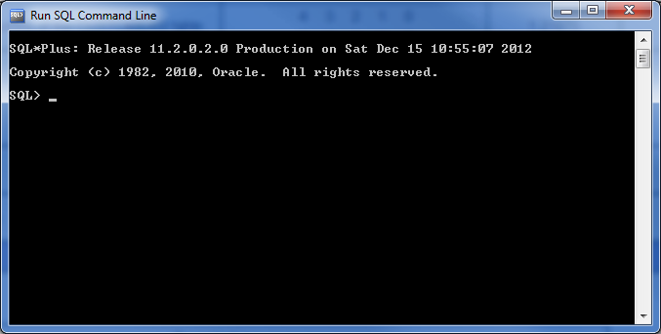
- You will see a Login screen and the SQL> prompt.
- Type " connect".
- Enter " System" as the user name when presented with the "Enter user-name" prompt.
- Enter the password that you selected in the setup program when presented with the "Enter password" prompt.
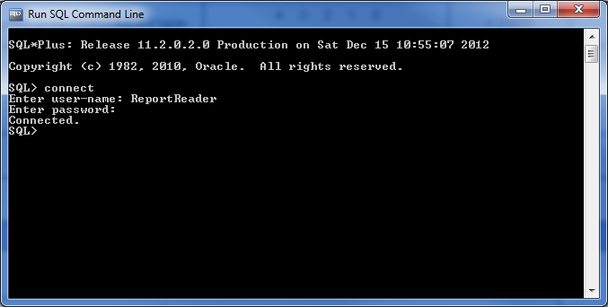
- You should see the SQL> prompt.
TABLE: PRODUCTS
COLUMN NAME | DATATYPE
Product_id | Varchar2(6); values should be like P00001, P00002, and so on. The first character should always be P.
Description | Varchar2(20); value should be NOT NULL.
Qty_on_hand | Number(10); value should be NOT NULL.
Reorder_level | Number(5)
Price_per_unit | Number(8,2)

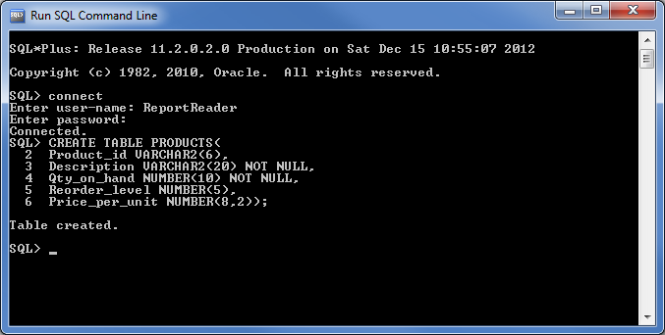
TABLE: CUSTOMERS
COLUMN NAME | DATATYPE
Customer_id | Varchar2(6); the first character should always be C; for example, C00001, C00002, and so on.
Customer_name | Varchar2(20)
Address | Varchar2(30)
Ph_no | Number(8)
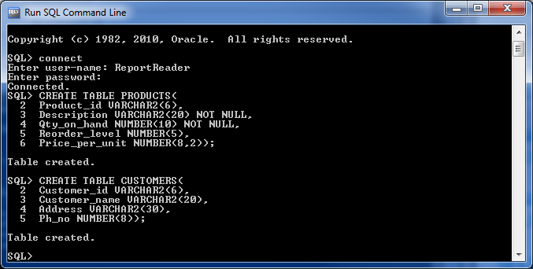
- Alter the PRODUCTS table to add a primary key on the Product_id column.
- Alter the CUSTOMERS table, and add the columns City as "varchar2(20)" and State as "varchar2(20)."
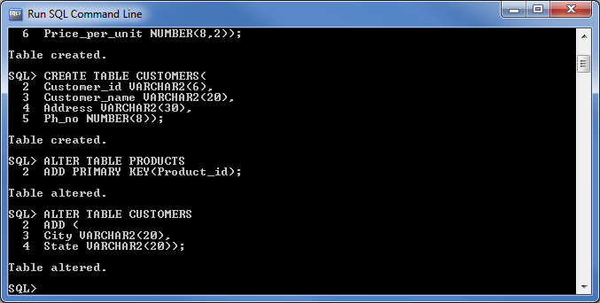

- Alter the CUSTOMERS table to delete the Address column.
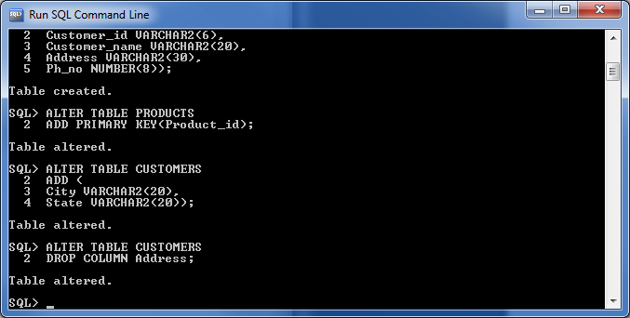
- In the CUSTOMERS table, make the columns Ph_no and Customer_name NOT NULL.
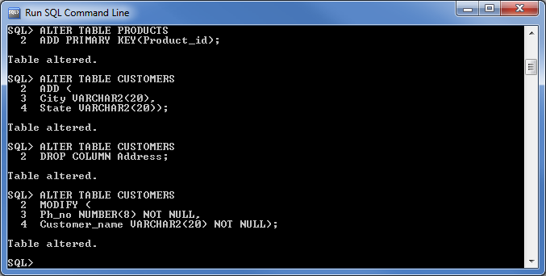

- Insert the following data into the PRODUCTS table.
Product_id | Description | Qty_on_hand | Reorder_level | Price_per_unit
P00001 | Pen | 800 | 100 | 0.33
P00002 | Pencil | 700 | 150 | 0.15
P00003 | Notebook | 950 | 70 | 4.25

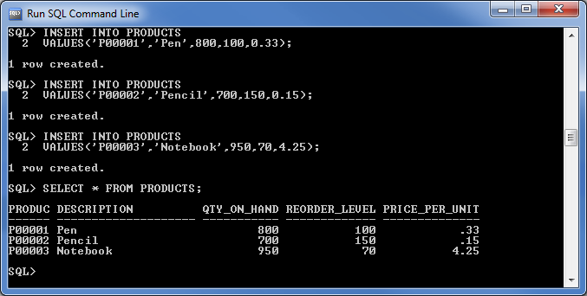
- Modify the value of Qty_on_hand of product P00001 to 1000.
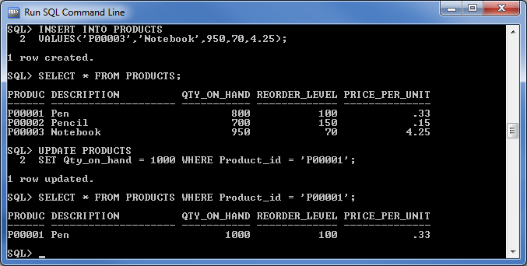

- Delete all the rows from the PRODUCTS table.
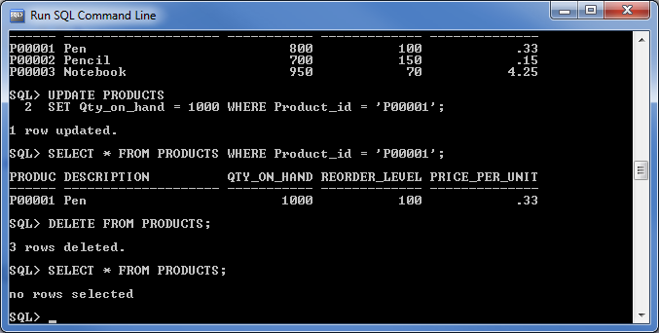
- Truncate the CUSTOMERS table.
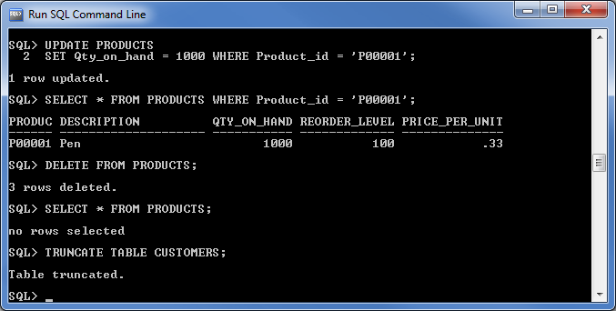
- Delete the PRODUCTS table.
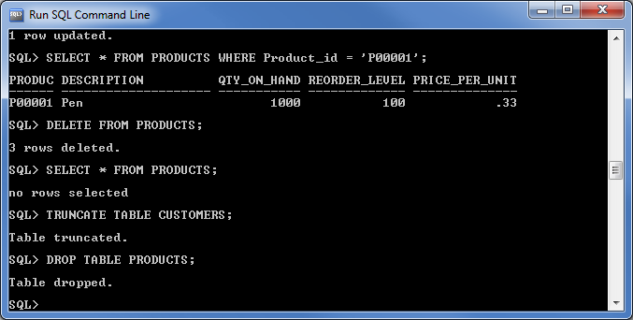
Reference
Coronel, C., Morris, S., & Rob, P. (2012). Database Systems: Design, Implementation, and Management (10th ed.). Boston, MA, USA: Cengage Learning.

