Running Head: CALCULATING AVAILABILITY

Calculating the Availability of a Real Estate System
Jered McClure
Walden University

Calculating the Availability of a Real Estate System
The entire probability diagram for the real estate system is laid out below in figure 1:
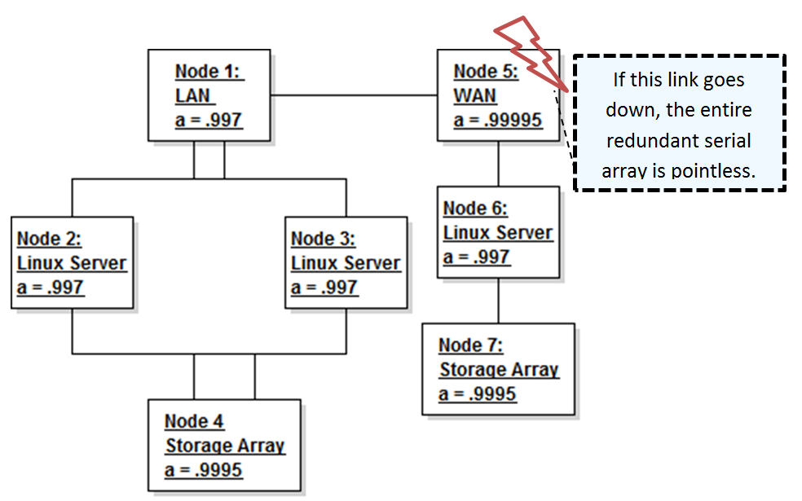
Figure 1
Essentially, the primary nodes are in the left complex array, and the redundant nodes are in the right serial array. The primary weakness of the entire plan exists in Node 5, the WAN. If this connection goes down, and the primary complex array goes offline, the entire system is a moot point. However, adding in a redundant link would not increase the overall system availability. This is because the Linux Servers and the LAN have such poor availability that no matter the redundancy put into the connections, the availability will remain the same. As such, a major way to improve upon the overall system availability would be to increase the server availability on the right, and the LAN availability on the left.
Still, the current system availability can be calculated as follows. First, the complex array is simplified into a standard serial array by calculating the overall availability of the redundant connection between the two Linux servers. You will notice that the overall redundancy availability is much higher than their individual availability, were this implemented on the right as well, the overall system availability would increase.
Figure 2
Next the left and right serial arrays are simplified down to their base availability values. Note that individually, they both maintain the same availability. This is because the LAN on the left maintains such a low level of availability that it lowers the complex array’s availability dramatically.
Figure 3
Finally, the overall availability of the redundant array is determined. Even though each array’s availability is quite low, their overall availability is as close to five nines as makes no difference.
Figure 4
With an availability of five nines, the entire real estate system is capable of maintaining mean recovery time of approximately five minutes (Digest, 2011, p. 4). However, this is just an average, and could be different over the course of ten years. For instance, the system could go down for five minutes every year, or for fifty minutes one year. That being said, this level of availability may be quite sufficient for the RTO of a real estate firm.

Reference
Digest, A. (2011, July). Choosing a Business Continuity Solution Part 1 - availability Fundamentals. Retrieved April 25, 2014, from The Availability Digest: http://www.availabilitydigest.com/public_articles/0607/choosing_bc_solution_1.pdf
Digest, A. (2011, July). Reliability Diagrams. Retrieved April 25, 2014, from Availability Digest: http://www.availabilitydigest.com/public_articles/0607/reliability_diagrams.pdf
Stern, E. M. (2003). Blueprints for High Availability (2nd ed.). Indianapolis: Wiley Publishing, Inc.

