Running Head: FAILURE MITIGATION

Failure Mitigation: Return on Investment
Jered McClure
Walden University

Failure Mitigation: Return on Investment
Case Study A
Case study A has two types of downtime to consider: a workday outage, and an after-hours outage. A workday outage is likely going to cost the organization a lot more due to having staff on hand being paid to wait for the system to come back online, and then being paid overtime to catch up on orders. On the other hand, an after-hours outage will have fewer staff on hand to deal with the outage (likely majority IT) and thus being paid overtime only. However, transactions occur around the clock, so profit is lost no matter what time of day the outage occurs.
So the following figures must follow:
- The organization earns approximately $500 an hour
- Staff are paid during work hour outages $1400 per hour of outage time
- After hours outages only require staff payments of $600 per hour
- The median hourly loss is then $1500, or $25 per minute
Below is a table showing these calculations, note that the outages are quite literally losing one day’s worth of profit each year:
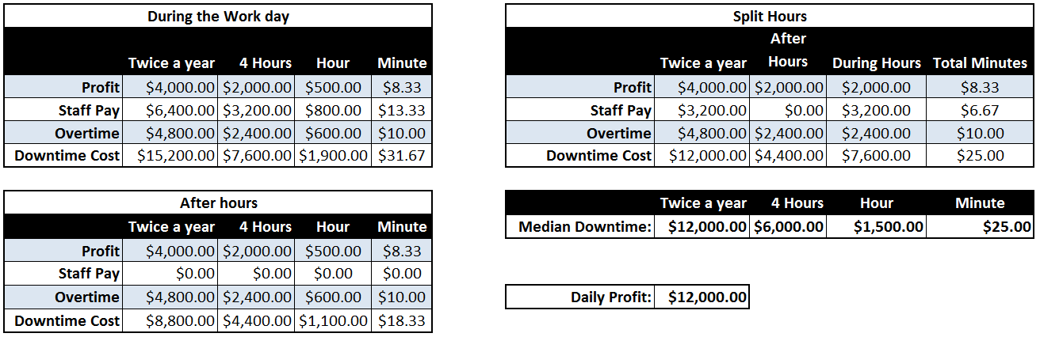
To determine the total return on investment, the organization has stated it wishes to run a secondary server to run as failover at a cost of $35000. Unfortunately, no other costs were given. However, it must be assumed the organization is going to pay for IT staff and upkeep. Nonetheless, these figures were not provided so cannot be plugged into the overall calculations. This is just something that will need to be considered by management.
Determining overall ROI means finding the before and after event values. The Outage types for both will be: Crash and Reboot, Crash and Reboot After-Hours, and Failover Testing. The before event will have zero values for all Failover testing as this does not currently exist. During hours, an outage will affect 100% of users, after hours will affect 60% of users as staff will not be engaged. For the after event, the failover test will affect approximately 50% of users, since it will be controlled and done after hours with prior warning.
Below is a graph showing these calculations:
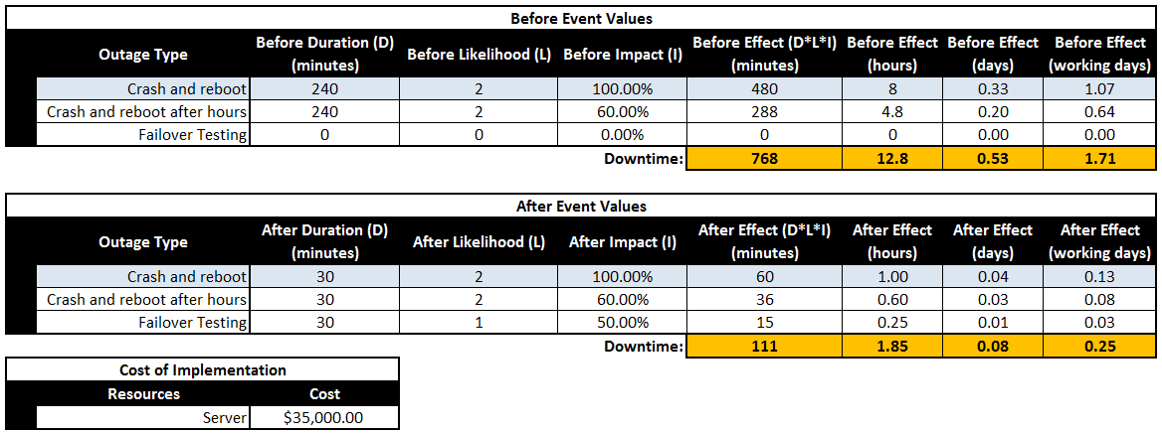
This leads us to the final results of the return on investment for the new failover server. Plugging the value of $25 as the downtime cost per minute, a total savings per minute is found of $16,425.00 with a total return on investment over five years of 46.93%. This is definitely a gain which should not be overlooked by the organization.
Below is a graph showing the ROI calculations, note that the overall savings for the implementation of a second server is actually greater than the maximum downtime cost estimate:
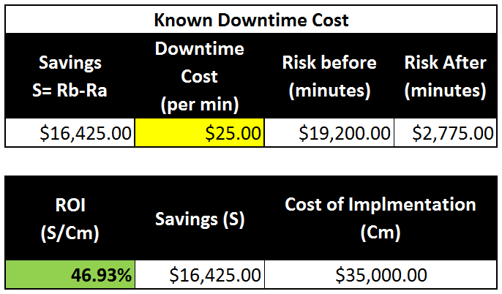
Based on these raw numerical values, the organization should definitely implement the new server. However, from a technical point of view their technology department should really review why the outages are occurring. Implementing a failover will reduce their time to recover, but not necessarily the times between failures. There is also the slim possibility that the failover server will fail at the same time the primary server goes down, in which instance there is no cost savings to be had, at all.

Case Study B
In case study B a securities firm has the potential of losing $5million worth of trades per minute, with $50,000 of that being their own profit, based on their current system’s failover recovery time. Unfortunately, there is no way to decrease the time to recover, but there may be a way to decrease the time between failures. This would require the implementation of a system which could cost as much as $2million.
Below is a graph outlining before system upgrade downtime and after upgrade downtime:
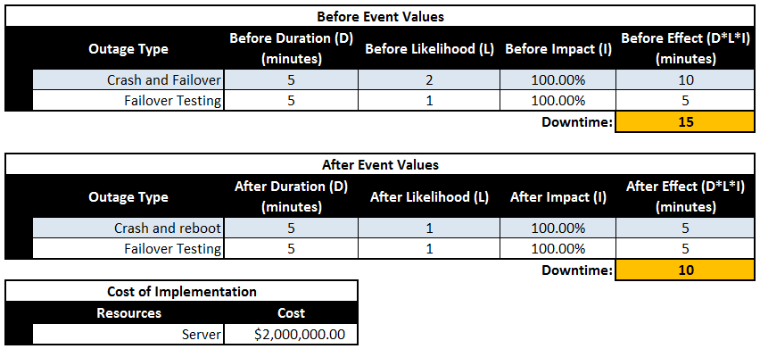
The first thing to consider is whether the organization should base its presumptions on the overall amount being lost through trades, or the value the organization itself is losing from profit loss. As a business, one would think the firm should consider its profits above all else. However, some of those trades may actually directly impact the value of the organization if those trades were value adding to the organization itself (e.g. entities making trades of the company’s stock).
Below is a graph showing the value lost on both profit and trades:
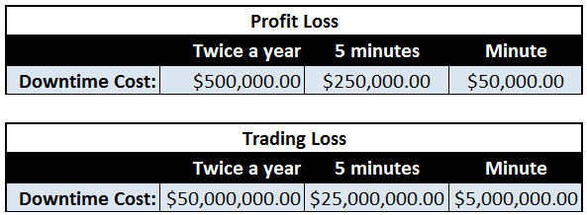
A couple of things to consider about the overall profit and downtime values, no values were given for user costs or staff wages. This is primarily because the failover time is so tiny as to have no effect on human work interactions. The failures in question strictly occur at a system level where trades occur faster than human reaction can pick up. As such, failover automation is highly critical to organizational profit.
Now that the profit and trading losses have been identified, the return on investment can be considered. From a strictly profit point of view, the overall ROI is actually quite low, considering that the system is going to cost the organization $2million, it is only going to save the company $250,000, or a ROI of 12.5% over five years. However, when taking into account the overall trade value, and the fact that some of the trade commission goes to brokers who would leave the organization if they are not paid, the ROI jumps up to 1250%. This is a massive cost savings, and as such, the failover server should be implemented.
Below is a graph outlining the two points of view, note specifically the Trade Value ROI:
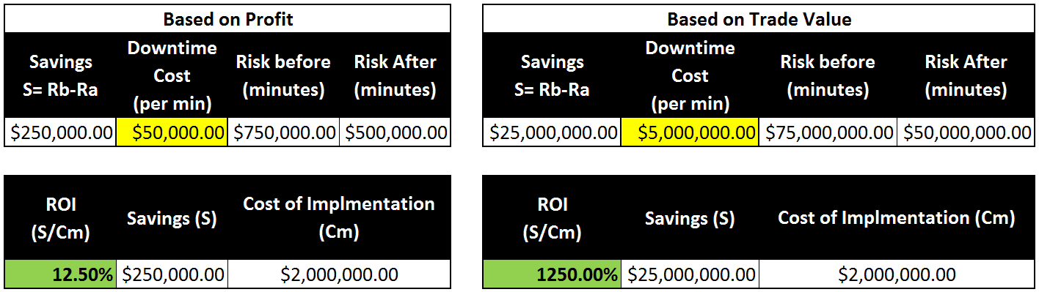

Reference
Stern, E. M. (2003). Blueprints for High Availability (2nd ed.). Indianapolis: Wiley Publishing, Inc.

