Running Head: HCI AND AUDIBLE.COM

Week 1 Application 1: HCI Review of Audible.Com
Jered McClure
Walden University

Week 1 Application 1: HCI Review of Audible.Com
“Audible is the world’s largest producer of audiobooks; it has served millions of listeners and continues to move literate listening closer to the media and entertainment mainstream” (Audible, Inc, 2012). The Audible site is built around the ease of finding what you want to read, and the social aspect of sharing what you as a reader believe is a good book. It is decidedly text based with a few graphics, which makes the site highly responsive, even on a low bandwidth internet connection. That being said, this does mean that new comers to the site may find they have a sense of information overload since there is so much being shown to them.
Home Page:
After the initial blast of information, the ease of using the site is actually quite simple. The search function in the upper left hand corner allows the user to go straight to the book/author/reader they would like with minimal fuss. For instance, typing in the word “Shadowmarch” immediately takes one to a page listing all audio books with that subject/title:
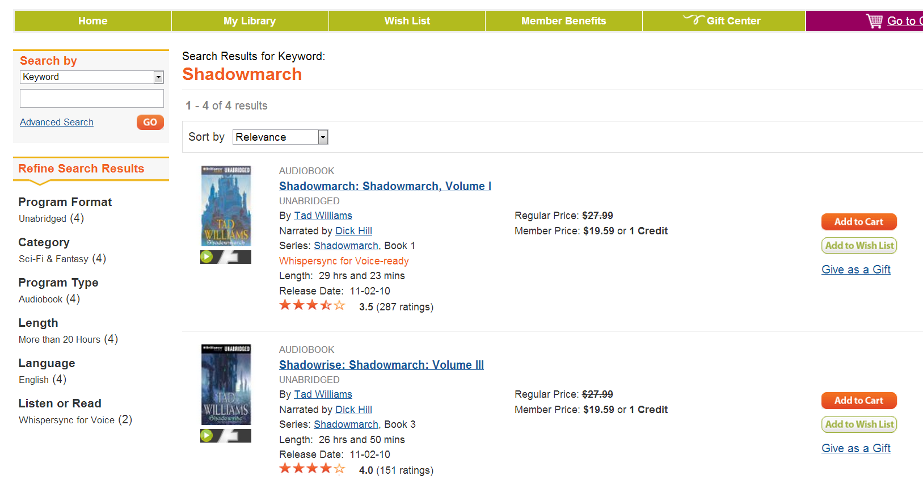
Hovering over images of books brings a pop up alt text box which shows the title of the book, how long the book is, who it is by, who narrated it, how readers perceived the book to be based on their social rating, the synopsis of the book, and another reader’s brief comment on the book:
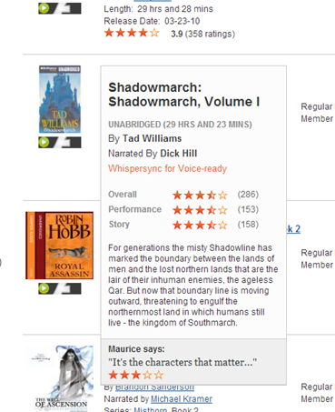
As for graphical buttons, their alt text is simple and to the point, describing exactly what the button will do if you press it:
The Audible website complies with the social and global aspect of HCI (Te'eni, Carey, & Zhang, 2007, p. 6). It allows users from around the world to purchase books, and rate books on how they perceived the performance to be. This means users can not only rely on paid critical reviews of audiobooks, but also on peer review:
Giving users this power to rate and review, not only ensures repeated customers to the site, but increased sales on high performance books. On the downside, books that do not perform well will get horrible reviews resulting in lowered sales. That being said, the bad reviews will not reflect severely on the site, rather on either the book quality or the book performance.
There is also a great deal of behavioral decision tracking and alteration. Throughout the site, users are constantly bombarded by pictures of other books as well as advertisements for other novels. On top of this, best performing books are always listed first and recommendations to listeners are based on intricate meta-information about the user’s shopping and site usage habits:
However, this meta-data can lead to some incongruent recommendations, for which users may not be happy about.
With this, the site’s overload of text, incongruent meta-data match ups, and reliance on Adobe Flash lead to some sticking points for users. While the text does mean the site is easy to load on low bandwidth connections, users are inundated with an overload of information upon entering the site. Reducing the amount of visible text and increasing graphical representations would reduce performance, but lower the amount of data overload on the user’s part.
The meta-data gathered on users through their use of the site can be a bit flawed at times, leading to recommendations and advertisements which are not useful for the user or the selling of books. Also, the site does allow users to preview audio books. However, these previews are done through third party software, Adobe Flash (Adobe Systems Incorporated, 2012). While this is not always a stickler for users, HTML 5 now allows the embedment of voice files, which means that Flash can be retired for more open source files that do not require additional software for the user to install.
Overall, the site’s simplicity, social interaction, and global perspective allow for user interaction in a global economy. The site is easily traversed, with text and graphics leading exactly where they say they will lead, leaving little room for user error. Socially, users can link their Facebook accounts to their Audible accounts and provide social commentary throughout their entire social network. Globally, users in different countries (for instance, Australia) are able to use the site to purchase books that would otherwise cost more in their locale or never arrive due to import restrictions. In essence, Audible have taken into account the time to learn how to use their site, its performance speed, user error ratios, and user satisfaction. While information retention does leave some room for improvement, the site itself is quite usable in terms of HCI (Te'eni, Carey, & Zhang, 2007, p. 4).

References
Adobe Systems Incorporated. (2012). Flash. Retrieved October 18, 2012, from Adobe: http://www.adobe.com/products/flashplayer.html?promoid=DJDWD
Audible, Inc. (2012). History. Retrieved October 18, 2012, from Audlbe.Com: http://about.audible.com/history/
Audible, Inc. (2012). Home. Retrieved October 18, 2012, from Audible.Com: http://www.audible.com/
Te'eni, D., Carey, J., & Zhang, P. (2007). Human Computer Interaction: Developing Effective Organizational Information Systems. Danvers, MA, USA: John Wiley & Sons, Inc.

